**Shipbuilding  Method Of Concrete Joint Wood Innovative Boat Will Reduce Structural Wood Sources**

Nusa Setiani Triastuti1) and Budhi Hascaryo Iskandar2

1) Lecturer in Engineering Faculty, Krisnadwipayana University, Jakarta, Indonesia  [nusasetiani@unkris.ac.id](mailto:nusasetiani@unkris.ac.id) SCOPUS ID 57170765800 ORCHID  0000-0002-2608-7648

2) Lecturer in   Fisheries and Marine Science Faculty.  Intitut Pertanian Bogor, Indonesia  budhihascaryo@apps,ipb.ac.id

Exploration methodology based on standards of concrete, wood, building structure, and the author's experiences in the construction field since 1983.

2.1 Data needed

The data of the purseine vessel needed (Fyson, 1985)  [14]

include:

(1) Data on the dimensions of the ship's structure, namely the dimensions of the wooden hull, wooden beam, wooden and concrete frames, wood height with concrete height, and keel concrete

|  |  |  |  |  |  |  |  |  |  |  |  |
| --- | --- | --- | --- | --- | --- | --- | --- | --- | --- | --- | --- |
| Cw | Cb | CΦ | Cvp | Cp | LOA  (m) | LPP  (m) | LWL  (m) | B  (m) | D  (m) | d (m) | BWL |
| 0,777 | 0,504 | 0,741 | 0,649 | 0,680 | 25,00 | 20,50 | 20,70 | 6,50 | 1,33 | 1,00 | 6,10 |

1. Lines plan  (Table 1)

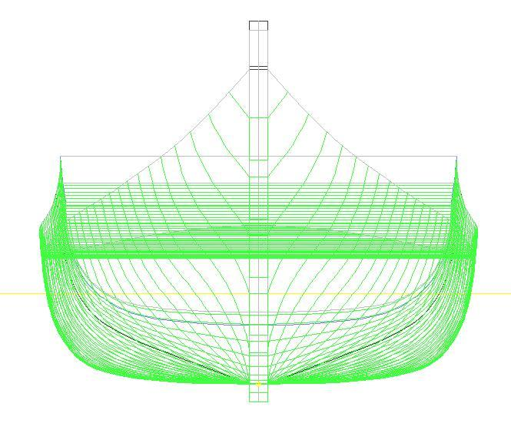

1. Table *offset (*Figure *1)*
2. Construction profile plan (Figure 2)

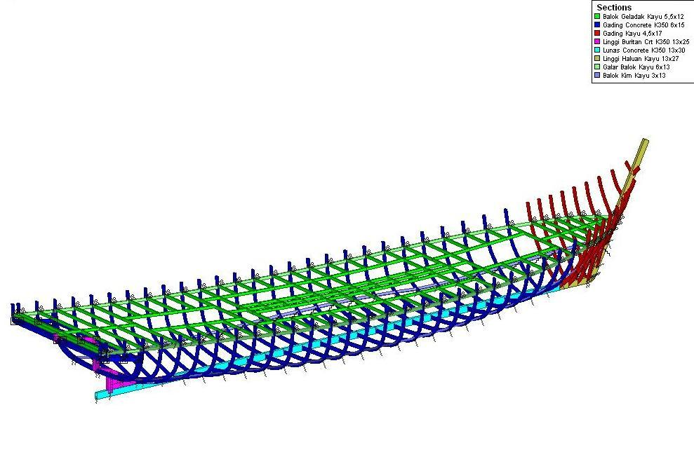

1. In addition, it is necessary to calculate and structure drawings, and mechanical and electrical images.  (figure 3)

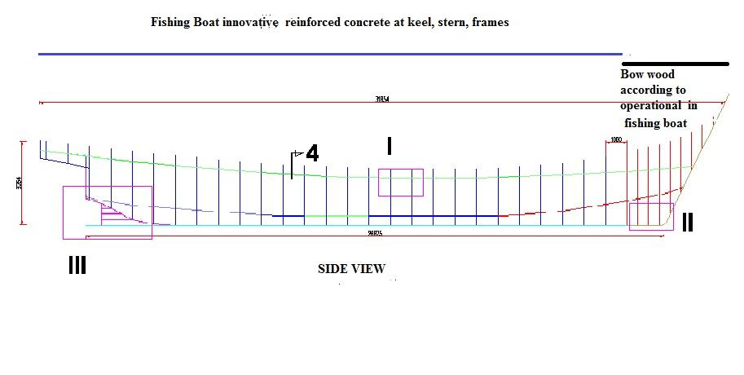



Detail II is a concrete keel, wooden bow, and wooden hull  (Figure 4a)

Detail III is a concrete keel, concrete stern, and strenpost  (Figure 4 b)

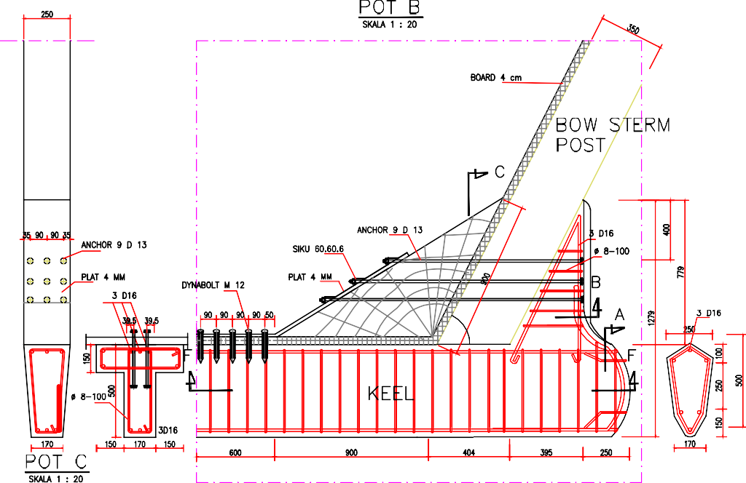

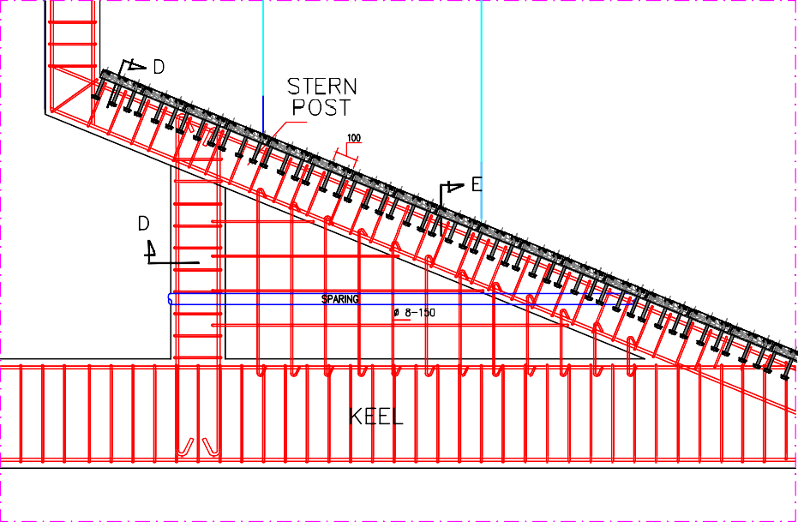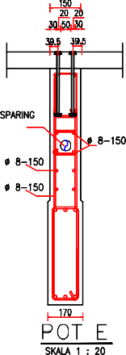



Detail II is a concrete keel, wooden bow, and wooden hull (Figure 5a)

Detail III is a concrete keel, concrete stern, and strenpost (Figure 5 b)

Figure 6. Bilge Stringer and wood frames

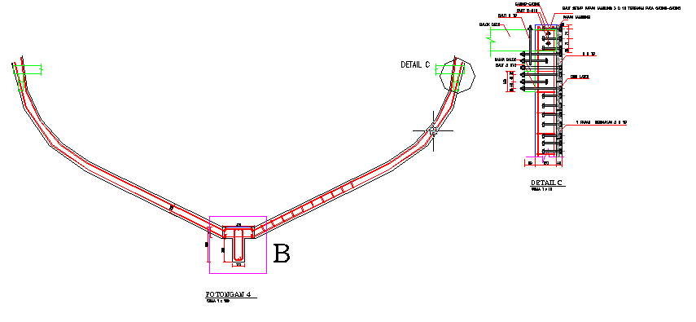

Figure 6. Bilge Stringer and wood frames

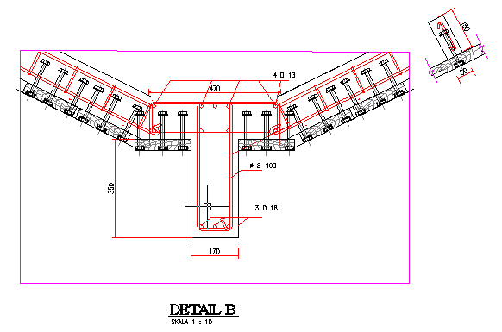

Figure 7

2)  Bilge Stringer and wooden frames (detail C). Completed Connection with frames Wood (detail B).

 All documents must be made communicative, clear, detailed, and complete

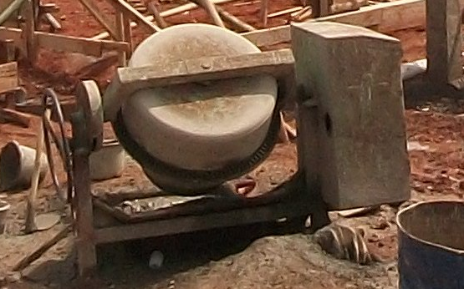                                  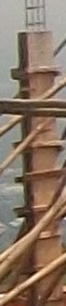

Figure 8                                                                                  Figure 9

Photo 1: Concrete mixer for mixing concrete    Photo 2: Examples of formwork

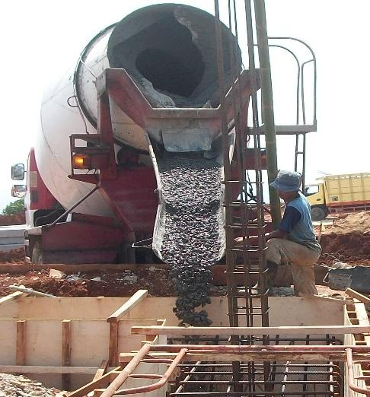

Fgure 10 :Foto 3: Gutter for casting concrete

Availability of data and materials

Semua daa tersedia di manuscript

Competing interests

No conflict of Interest

Author selves funding for research and publication

Funding

No funding

Authors' contributions

Author 1 :Substansi and detail manuscript

Author 2 : input of wood ship for fishing

Acknowledgements

Thank you for information ship expert