POTENSIAL of Water Transportation for Tourism Special Region in Jogyakarta Province

Nusa SetianiTriastuti *

*Civil Engineering Department, Faculty of Engineering, Krisnadwipayana University.

Email :nusasetiani@yahoo.com.
Abstract
Special Region of Jogyakarta Province should utilize water transportation to be unique,culture local,reduce traffic jump. Along the rivers and watersheds Progo,Opak river, gajahwong,code,winongo river, many tourist locations close to five rivers

The objection of increasing foreign tourism in Jogyakarta in order to sustainable protect the environment, awaken the community to clean up the river, motivate the community to be healthy by multiplying O2 , clean river and beautiful scenery, increasing the income of the community,

Survey of every long holiday happened crowded everywhere, Secondary data used the amount of tourism ,geography, geology, river map, rainfall and hydrological data, the population in the upper river, sustainable tourism in Venice by water transport
Argument of potensial tourism, engineering issues, environmentally sustainable,
financing by utilizing the potential of nature, community culture, . Analyzed to develop tourism with main stream water transportation.Of the five rivers with ten criteria that are close to the tourist object, the community is more educated, the community supports, the volume of water is high, the catchment area is arranged, the big discharge, the lava vomit is smaller,the river is little meandering, there is parking space, cheap in the construction

Conclusion of the completion of engineering is not difficult as long as the allocation of costs for gradual surveys, laboratories, design and physical implementation to achieve optimal results, Local governments and tour manager will provide funds. If water transportation can be implemented will be very interesting tourism especially abroadwho is still under 10% .

Key word :Selected river criterion, preserve the environment, Water transportation, Sustainable tourism,community partipation.
- INTRODUCTION
According to Government Regulation No 38/2011, the river is a natural or / or artificial water supply or container in the form of water drainage network along with the water inside, from upstream to estuary, with right and left boundary by line border. River as the Heart of the city has an important role in survival
In the city of Jogja there are three major rivers as the central of the City such as Gajah Wong River, Winongo River and Code River. One of the rivers that deserves the spotlight is the Gajah Wong river. Behind the beauty and splendor of the city of Jogja, there is still one urgent thing that is still neglected and received less attention, especially the river Gajah Wong.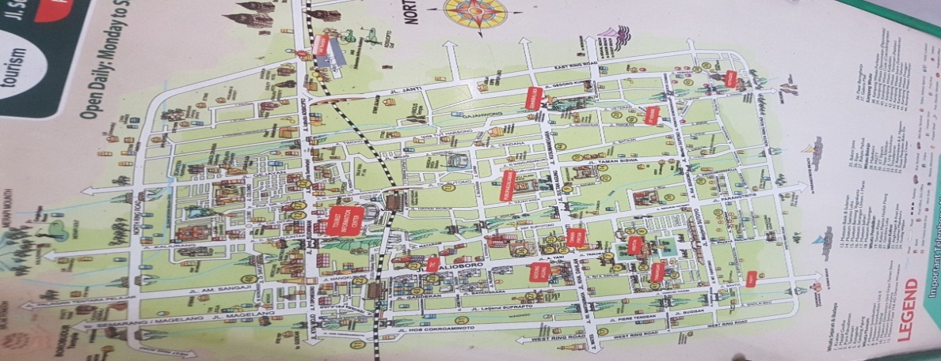Figure 1.Code,GajahWong,Winongo river flow tourism place in Jogyakarta city

This is very potential as a means of transportation, recreation, clean river, preserve the environment, green life. The potential of the five rivers must be explored and minimized by the engineering approach.
Special Region of Jogyakarta Province is interested tourism . Data 2015 shows 4,122,205 people in 2015, most tourism in December, after that in May, with the number of foreign tourists is still 308,485 people or 7,48% according to table 1.
Tabel 1. Number of Tourists to DIY Year 2015 (per-month and type of accommodation)Tourism statistic, Tourism department,D.I.J Province 2015
No. | Tourist | Jan | Feb | Mar | Apr | May | June | July | Agst | Sept | Oct | Nov | Dec | Total
I | Foreigner Tourists
 | Star Hotel | 15,125 | 13,759 | 16,412 | 19,391 | 19,324 | 19,627 | 23,174 | 26,371 | 19,383 | 20,607 | 18,700 | 20,098 | 231,971
 | Non Star Hotel | 5,626 | 5,184 | 6,321 | 7,465 | 6,839 | 6,735 | 7,676 | 7,912 | 5,363 | 5,812 | 4,739 | 6,842 | 76,514
 | Sub Total | 20,751 | 18,943 | 22,733 | 26,856 | 26,163 | 26,362 | 30,850 | 34,283 | 24,746 | 26,419 | 23,439 | 26,940 | 308,485
II | Local Tourists
 | Star Hotel | 131,067 | 105,407 | 118,158 | 133,985 | 160,235 | 134,527 | 93,501 | 112,742 | 127,097 | 147,675 | 135,829 | 183,073 | 1,583,296
 | Non Star Hotel | 171,132 | 152,638 | 180,906 | 182,482 | 225,486 | 199,574 | 140,879 | 170,242 | 162,067 | 191,670 | 198,153 | 255,195 | 2,230,424
 | Sub Total | 302,199 | 258,045 | 299,064 | 316,467 | 385,721 | 334,101 | 234,380 | 282,984 | 289,164 | 339,345 | 333,982 | 438,268 | 3,813,720
GrandTotal |  | 322,950 | 276,988 | 321,797 | 343,323 | 411,884 | 360,463 | 265,230 | 317,267 | 313,910 | 365,764 | 357,421 | 465,208 | 4,122,205
The objection of increasing tourism in Jogyakarta in order to sustainably, protect the environment, awaken the community to clean up the river, the environment, motivate the community to be healthy by multiplyingO2/,clean river and beautiful scenery, increasing the income of the community,Progote
Two major watersheds (DAS) in DIY are Progo waters in the west, and Opak-Oya watershed in the east. The famous rivers in DIY include Serang River, ProgoRiver, Bedog River, Winongo River, Boyong-Code River, Gajah Wong River, Opak River, and Oya River.Potential to be studied river engineering is river progo, opak, code, gajahwong and winongo.
Progo River is an area of ​​2380 km2 that passes the province of Central Java and DI Yogyakarta. Progo River is one big river that passes Jogyakarta city. River basin with a river length of 140 km, but 75% flow in Yogyakarta.Progo River is one of the river great that crossed the city of Yogyakarta.While in the estuary of the river Progo is famous as a sand mining area.
Upper riverOpak 65 km long in the mountain Merapi flows to the south with the estuary overlooking the Indian Ocean on the coast Samas. This river passes the west side of Taman WisataPrambanan Temple. DAS 638.89km2. The average monthly water flow of the Opak River is about 12.35 m3 / sec with a maximum of 83.2 m3 / sec and a minimum of 1.89 m3 / sec..
Most people's dream river is a clean river and protected from pollutants. But what happens around the river Gajah Wong Jogja, especially located on the east. Pile of garbagemostly plastic waste food wrap.has become a common sight for people around the river.
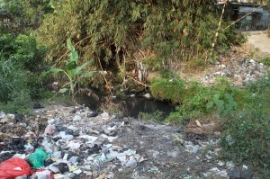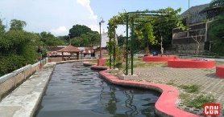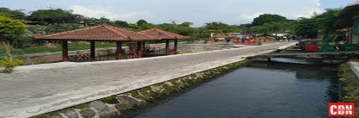Fig.2.Gajah Wong River Fig.3.A once dirty place can be so clean and comfortable to enjoyPemerti Code cooperates is done through cleaning of river area and surrounding area. Clean river activities conducted since mid-2015 still continues today.Many participants jumped directly into the river Winongo with a start at Kragilanand finish in Tegalrejo.Some are using tires, some are using rubber boats..However, all participants of the river retreat have been equipped with helmets and buoyswhen doing the trafficking.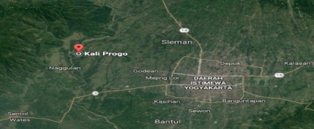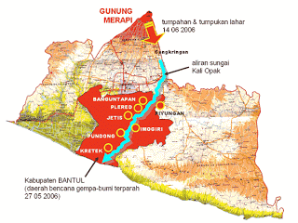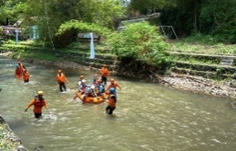Fig.4.Progo river divided Sleman,KulonProgoDistrictFig.5Opak River MapFig.6Winongo River
2..METHODS
Conducting survey in DIY Province. During the holidays, writers and friends always get solid access / traffic to the tourist area. Interview of primary data of traffic jump, condition along 5 rivesr with some people and interview living in Daerah Istimewa Yogyakarta. Analysis based on secondary data and primary data only to validate. Secondary data is
- Map of KulonProgo infrastructure. Ministry of Public Works
- Tourism Statistics 2015. Department of Tourism
- Map of tourism Jogyakarta city
- Rainfall and hydrological data from Metrology andGeophysics
- River map, long, width, depth, layout, profile of the river
- Geografi map of the internet Bakosurtanal
- Geological results from the Internet Ministry of ESDM
- Design and Reserved by Citraweb Nusa Infomedia
Secondary Data Analysis shows it as a method of research. Judge (1982: 1; dinukil Johnston, 2014: 620), "Secondary data analysis remains an under-used research technique in many fields. Given the increasingly availability of previously collected data to researchers, it is important to further define secondary data analysis as a systematic research method. " Heaton (2004: 16; dinukil Andrews, et.al., 2012: 12) formulates the secondary data analysis (ASD) as a research strategy which makes use of pre-existing quantitative data or pre-existing qualitative data for the purposes of investigating new questions or verifying previous
The analysis of secondary data can thus be formulated as follows.
- ASD is not a method of data analysis, but a method (strategy) research. Therefore, according to Andrews et al (2012), data analysis methods such as grounded theory (analysis of qualitative data) and stastisic analysis (quantitative data analysis) can be used by secondary data analysis methods.
- ASD uses or utilizes secondary data, ie data that already exists. In this case ASD researchers do not collect their own data, either by interviews, questionnaires or listings, performing tests, using a scale of scales or likert scale, or observation. Secondary data that can be data of research results, dapt also in the form of institutional documentary
- The purpose of ASD, according to Heaton, can be to explore and discover new research questions, or to test the results of previous studies.
Andrews et al., For example, notes the aims of ASD's research objectives, among others, to:
- Apply new research problems-explicitly research with new research objectives different from previous studies (Heaton, 2004),
- Use old data to generate ideas (fielding, 2004),

- ARGUMENT

Overcoming the long distance, the most possible alternative water transportation, because Jogyakarta in pass several rivers, potensi on the five rivers
The obstacles and problems of water transportation in D.I JogyakartaProvinci are:
- River as a source of life that needs to be preserved as it is, the community still cult the areas that are considered mystical
- River ismeandering
- Easy to shallow, due to the sediment of strong river mouth flow from Merapi volcano across the riverof Opak,Progo,Gajah wong,Code,Winongo,where the cold lava bursts from all the rivers
- Many large stones, dangerous for ships.
- Not yet organized as water transport
- Untouched for water transportation
- The social environment is not yet supportive, still less caring
- Engineering has not been done so it is still natural.
- The mouth of the Opakriver is a lot of mangroves and grasses for fodder for people's lives that should not be disturbed or damaged. The garbage along the river flow Gajah Wong, river water color has changed into black and turbid due to pollutants derived from organic waste sediment. Code River most of the river waste comes from households
- The water of the Opak River has reduced by about 40 percent, but now it is recovering after a reforestation in the watershed.
The scale of potential river sequences is used as water transportation with the following criteria:
1. The number of tourist objects that are passed and the location of the tourist attraction that became the city of Jogyakarta in special and the province of Jogyakarta in general
2. A more educative community structure, concerned with the natural environment and social environment, has a minimum education level of First High School for Rough and Minimum bachelor for water transportation management and tourism object.
3. Community supports water transportation and willing to manage with sunguh really
4. The current is heavy, the volume of water is high and the water level is high so that it meets the draft boat and draft ship
5. Catchment area is eligible either broad or water storage
6. Volume, water level, river flow discharge is still high and heavy
7. Lava vomit from the upstream relative of the least / small
8. The flow of the river is relatively not too meandering for convenient passenger boat or ship
9. Still can make the location of the bus parking tour, minibus and motor around jetti.
10. The cost of physical execution is relatively inexpensive, the shortest implementation time, the natural, social environment is very supportive.
Constraints or problems are not difficult to do a solution as long as there is willingness and support of local government and civil service or chairperson of indigenous community. In order to be accepted by the community and local government.
The Venice Lido is reinventing itself as a hub of sustainable tourism is also one of those 2017. The Italian government has decided to work alongside Ocean and Construction Engineers in safeguarding Venice by building mobile barriers acrossthe lagoon inlets surrounding the city.Tempers have been frayed in the World Heritage-listed city this summer, with residents rallying against the daily influx of up to 70,000 tourist, many of whom are day trippers and cruise ship passengers.

- FINDING

The main obstacles and problems understand the culture and local wisdom of the river and the environment.Obstacles and problems that exist can be the strength of the sale value for touris especially from the abroad. The value of forces that appeal to tourism include:
- The people who still cult the mystical areas are given facilities so that they are localized and attractive to other regions or countries
- River winding impact on the river there are sides that settled and eroded. The eroded part is given a reinforcement, while the precipitate is made a sediment pond, so that it is allocated dredging. River meandering, when arranged as beauty. Winding avoids very heavy currents carrying large materials, thus endangering humans.
- Sediment ponds can be used as localized sand mining.
- Big stone as a place to step down, ride passengers ..
- Transportation of water to increase tourism interest because of close distance, unique transportation, unique customs, heritage buildings, crafts.
- The social environment will support for a better life by engaging in the management of water transport and green transportation.
- With a touch of engineering that takes into account the environment and uniqueness will add to the attraction of tourism.
The author will continue research on sediment laboratory research, soilstructure,rainfall, river volume, river water level, river flow. Engineering analysis should be thorough, appropriate solutions when supported with primary slope data, sediment samples, soil investigation, flow survey, flow rate, vomit lava, wide watershed, catchment area, river wall material.
Analysis needs to be done:
- Approach to society, adapting to culture
- Local wisdom should be explored to increase the added value of tourism
- The meandering river should be utilized to be beautiful and unique
- Easy shallow, with engineering is not difficult that is made sediment ponds, pond lava explotion before the sediment into the river.Engineering solution such as:overcoming the river is easily shallow,the decrease of river water the security because of rocks, sliding
- Boulder a valuable material to be placed in jetti, where tourism goes up, down river transportation
- Needs to be arranged by riverside, flow depth, transportation convenience, garbage can be provided on boat / boat and tourism location. River walls of concrete eg sheet pile so that not easily eroded compared to rock plastering.
- Transportation to tourist sites without machines, eg bicycle, beca, andong, wheelchair. Wheelchairs need to be connected to the back there is a power swing
- River transport by boat is used instead of vessel to minimize environmental damage
- Social environment needs to be arranged, managed, friendly service, Indonesian and English language skills, expertise in caring for and running water transportation.
- Analyze the success of other countries that have a sophisticated tourist location and successful water transport sustainable tourist visits.
- Organize the entire transportation of the river, transportation,jetty,boat or ship, transportation managers, payment systems, organize the social and natural environment
Initial solutions should be followed up with more detailed ,more mature research and review:
- Culture is a selling and enhanced value for tourism, unique, exciting water transport
- Local wisdom from home, accessories, batik cloth, should be performance on water transport., organize the social environment with the community and use batik uniforms
- River meandering there is a eroded side, side settles, it needs to be determined to avoid and resolveand should be utilized to be beautiful and unique
- Sediment ponds in one place if you want to dredge, easy and cheap. The structure jetti from the surrounding material by recognizing the behavior of the river from the laboratory results.
- Boulder natural material that is very useful for the structure of jetti and the safety of the cruise line and river wall.
- Boat with engine that analyzed strength, speed, minimize contamination,
- Transportation to the location without a machine that is andong, bicycle, wheelchair to get to the tourist location distance 2 km.
- River banks are arranged with rock structures that are potential for the river, the depth of the stream should be kept stable so that maintenance is necessary, the transport convenience is not subject to rain, heat, environmentally friendly machinery, cleanliness of the river, ships and tourist sites must be maintained boats and tourism locations
- Reforestation mainly catchment area of ​​ five rivers, reforestation in addition to increase the volume of water as well as beautiful scenery along the water transport.
- The social environment needs to be organized, improved, improved on-the-job training training, karmic arrangements, healthy serving of food or drink serving with hospitality, Indonesian and English skills, expertise in caring for and running water transportation.
- The manager of water and land transportation, payment system with e money and directly when using water transportation and tourist attractions ,
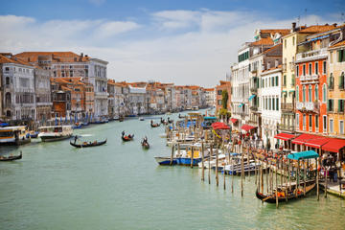
Figure 4. Venice water transportation

- CONCLUSION

The potential of water transportation in Jogyakarta Province in general and the city of Jogyakarta in particular is very large, because it passes in the central of the city, the traffic jump, In addition, the distance through water transportation is relatively shorter than crossing the mainland. Of these five rivers must necessarily be made potential scale with appropriate ten criteria design Reforestation in the catchment area to increase the volume of water and green scenery that gives the coolness of the eyes and oxygen .. Boat machine that is relatively small produces CO2. Management of waterways and accessibility tourism must be community-based, sustainable services, increasingly satisfying the tourists
Recommendations Water transportation is expected to be well realized, so that the Special Region of Jogyakarta Province become a tourism province used as an example in Indonesia and the world because of transportation to nonstop tourist area, short distance of fun. Ship shape and along the river to the tourist location made with Jogyakarta ornaments, art heritage is preserved to be a sustainable tourism province

Reference:
- Amirin. T.M .MetodePenelitianSekunder (Analisis Data Sekunder). 12 April 2015
- Aprilliani,F,Polusi : Sungai Gajah Wong SebagaiJantung Kota Jogja yang Terabaikan,2017
- DinasKepariwisataan DI. Jogyakarta .StatistikKepariwisataantahun 2015
- Forbidas, Ubah Sungai KumuhJadiKawasanEkowisata, JurnalisCyril- 2 Feb 2017
- KurniatulHidayah,MelihatKondisi Sungai WinongomelaluiSusur Sungai, 24 Maret 2018
- PeraturanPemerintah No 38 tahun 2011
- Schnabel J:Transporting a Schnabel Chanabel to Venice.A.Spectacular FAT Journal February, 3rd, 2012
- Solopos.com, Sungai Gajah Wong Akan DijadikanKawasan Ekodistrik,2015
- Sunandar,P. DaerahAliranSungaiDepartemenGeografiFakultasMatematikadanIlmuPengetahuanAlamUniversitas Indonesia ,TugasAkhir 2012
- TRB’s (Transportation Reasearh Board) Transportation Research Record: Journal of the Transportation Research Board, No. 2033

