**RETROFITTING ANALYSIS OF STEEL ROOF FRAME TO PRESERVE HERITAGE BUILDING 1921**

**Nusa Setiani Triastuti** **1), Rico Turnando****2) , Indriasari1)**

**1)** Researcher, Lecturer Universitas Krisnadwipayana [nusasetiani@unkris.ac.id](mailto:nusasetiani@unkris.ac.id), ORCHID 0000-0002-2608-748, ID SCOPUS 57170765800

**(2)** Profesional Engineer: [ricoturnando05@gmail.com](mailto:ricoturnando05@gmail.com)

**3)** Researcher, Lecturer Universitas Krisnadwipayana [indriasari@unkris.ac.id](mailto:indriasari@unkris.ac.id)

**Abstract**

The spirit of preserving heritage buildings as they originally became a big challenge during design analysis to remain original state, with no damage construction process. The objective of this research was to maintain the authenticity of the structure. roof covering. strengthening and detailing the roof, by analyzing the structure on the strength, stability, and deflection of the roof with Indonesian code 1729-2015 based on the American Steel concept. Analysis of dead loads, live loads, and the wind load, because only the roof was on the 3rd floor and the roof slope is 30o . The case study method was carried out with surveys and secondary data results from the investigation consultant in 2016. The results of the analysis of two truss members' roof 2L 70.70, need to be replaced with a double profile 2L 80.80, bolt connections with the provision that steel profiles, bolts, and rust anchors were replaced. Analysis of the 3-dimensional roof structure with software by calculating the compressive wind load of 75.82 kg/ m2, and the suction wind load of 57.37 kg/m2 according to the wind speed of 40 m/s. Conclusion steel roof truss meets strength, stability retains the original structure shape, accessories, roof, and tile roof

Keywords: fixed heritage roof, steel roof truss structure retrofitting, bolt connection roof frame, profile dimensions maintained, tile roof preserved

Highlight

The original shape of the roof remains, including the steel profile material, the research team must be careful by paying attention to the existing material so as not to fall hit on the survey team because the heritage building was not well maintained. While design paid attention to construction to be retrofitted safely, and retain as much as possible. The design can achieve stability, rigidity, and small deflection.

**Statements and Declarations**

The research team declared and fought for the 1921 building to be as original as possible, even though the level of difficulty and risk was high

**Background**

Architect of the Fermont & Cuypers building. The Building was built in 1921 to function as the Banking and Trade Office of the Chartered Bank of India, Australia, and China in Batavia (source Mandiri Bank). The sum 475 to 1993

Glass Patri by J. Sabel's en Co, Holland depicts Nusantara Plantation Commodities, namely the activities of picking tobacco leaves, pounding rice, carrying sugarcane stalks, picking coffee, and tapping rubber trees

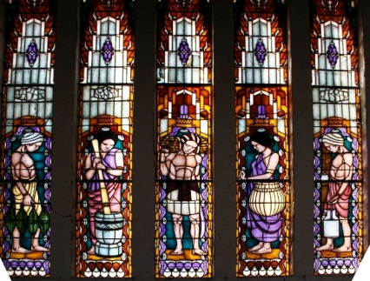

Figure 1 (source Mandiri Bank)1a. picking tobacco leaves, 1b, pounding rice, 1c, carrying sugarcane stalks, 1d picking coffee, 1e tapping rubber trees

**1. Introduction**

The heritage building is protected by the Regulation Of The Minister Of Public Works And People's Housing Of The Republic Of Indonesia Number 19 the Year 2021 Concerning Technical Guidelines For The Implementation Of Cultural Heritage Building Be Conserved Article 6. (1) b. Article 6. (4) c.

It needs to be repaired or strengthened so that it functions properly and can be enjoyed by the younger generation to explore the history of the Indonesian nation. Damage to the roof structure as a building protector can cause overall damage to heritage buildings. The research team identified the overall damage but in this paper, only roof damage is discussed

The Heritage Building was a construction building that was started in February 1921 in Jakarta. After the building was not used for office operations the Heritage Building was less maintained other than it was 100 years old, it needs to be retrofitted.

A small part of the roof truss elbow profile is porous in areas that were not protected by the roof so it must be replaced. The roof beam WF profile is still good. which are porous and are considered to have been replaced according to the dimensions of the existing roof truss. The input software is assumed to be non-roten and non-hollow because it will be replaced new steel profile

Analysis of the roof structure from the output of the software shows that the load-receiving results are smaller than the allowable stress of the steel. The purpose of this study was to analyze the reinforcement of the steel roof truss including bolt connectors, and anchors so that it achieved, strength, stability, and stiffness in the 1921 Heritage Building. Reinforcement analysis using SNI 1729-2015 regulations. with the help of software. The author tried to simple analyzed but big impact on the old and young generation that heritage buildings were in accordance with the original, retrofitted with a simple construction non-sequential that was easy for young engineers or workers to understand for build and scientific journal easy implementation

Historic earth structures are an important part of a heritage built around the world, with similar structural characteristics and performance levels. (Lourenço P.B 2018)

This manuscript on two main aspects: the urgent knowledge of construction engineering at the time the work is constructed and the ongoing linkages required between the various aspects involved in the process. ( Gutiérrez A.C, imenez M.B,2018)). The diaphragm is built on top of the existing structure without significantly changing the overall layout of the roof. The proposed retrofitting engineering primarily is defeasible, minimizes damaging the integrity of the building, and can be easily implemented in the construction of earthquake-resistant wooden roofs in new buildings. ( Giuriani E., Marini A, 2008)

The roof structures were an integral part of the architecture and should be treated with care because of their historical significance. Wooden structures are important sectors of historical relevance, architectural technology, and construction materials. Cestari. C.B, Marzi T (2018)

Assessing the early stages of iron roof construction and the evolution of iron roof structures four case studies of churches located in Brussels, Antwerp, and Gent, from the 1840s to the 1860s, through in-depth analysis. (Wibaut. R et all, 2019)

Long-span truss profiles require less material than structure profiles roofs to relate to the required width of the truss Rambhau P. R, Wakchaure M.R.(2017)

An alternative design to reduce the footing size avoids shearing of the integrated rigid frame in the floor between the foundations in the tension tie beam (Mangaluru, Karnataka,2018)

Rigid frame structure spans longer or equal to 30m cheaper without calculating the cost of the foundation compared to the span of 20m. rigid frame. (Martínez J.M et all (2004)

a function of the average wind speed in the area under study. It is an estimate of the number of damaged schools per area. The risk assessment proposed in this paper (Acosta T.S 2021)

The risk assessment proposed in this paper

The average wind speed in the studied area. Estimated number of damaged schools per region (Acosta T.S 2021)

Both trusses are designed and compared all internal forces, are economical, and evaluate the moments, and shear forces present along the critical sections with the same configuration area keeping all other parameters constant( Bláha. 2018)

Damage caused by aging and neglect. Construction The life cycle of the structure here is investigated through the various stages of the building's life built in 1902, and abandoned in 1984. The periods analyzed are: from construction to disuse and from disuse to the present day. The second phase of life significantly accelerates the ongoing degradation. (Basso N, Sgambi L 2018)

The design process consists of determining first the exact shape of the original roof, taking into account different types of evidence, and secondly the necessary modifications, to meet the structural standards. Such a design choice is far from a simple solution, a thorough multidisciplinary investigation involves the participation of different experts ( Piazza M, Riggio M, 2017)

In this paper, two main aspects contribute to the achievement of broader sustainability goals during the restoration and renovation of historic buildings exploring the relationship between structural rehabilitation of historic architecture and cultural sustainability (Bertagni S. et all 2018)

Two types of steel truss roof structures – K-series steel beams and arch trusses as prototype roof trusses. Nonlinear dynamic analysis which takes into account the material and geometric nonlinearity was carried out for this simulation study. Installing the steel truss roof structure prototype device in the intentionally attenuated force zone helps to reduce the displacement of the truss structure due to wind stress thereby reducing the risk of dynamic failure Zhang. L.B.Y (2012).

Helps reduce displacement of the truss structure from wind stress by installing force-limiting devices in the intentionally attenuated zone of the prototype steel truss roof structure thereby reducing the risk of dynamic failure (Yong Y.X et all,2017)

Four representative locations in China were investigated. Steel roof structure exposed to snow load

The studied roof reliability index was not sufficient to reach the target value. In addition a large partial factor for various snow loads (Kozak D.L, Lief A.B, 2015)

**2.Implementation**

Retrofitting the steel roof structure with the shape, profile, and shape of the existing roof covering so that the authenticity of the heritage building is maintained. The layout and shape of the roof as below

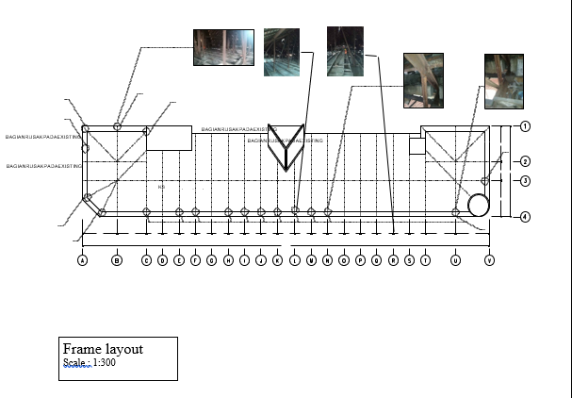

Figure 2. roof length of 102 m, width 21.6 m, height 5 m, with a distance of 7.4 m and 4.1 m truss.

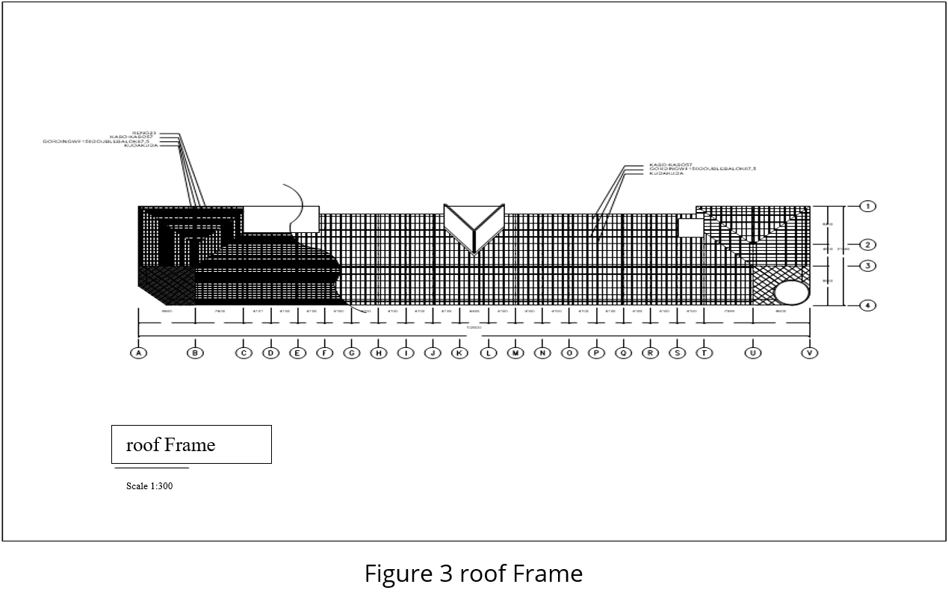

The layout of the existing steel structure is maintained as it is, with the following data:

1. 102 m elongated roof
2. Roof structure long 21.6 m
3. The span of the roof structure is 7.4, 4.35 m, 2.1 m
4. Roof slope 30o
5. Roof Truss 2L elbow profile 80.8.8; 2L.70.70.7, 2L60.60.6, L 50.50.5,L 40.40.4

In this analysis, the connection tool used bolts of 13 mm for steel profiles, and for anchors using 19 mm, the anchor length is 15 cm with A325 quality (high-quality HTB bolts).

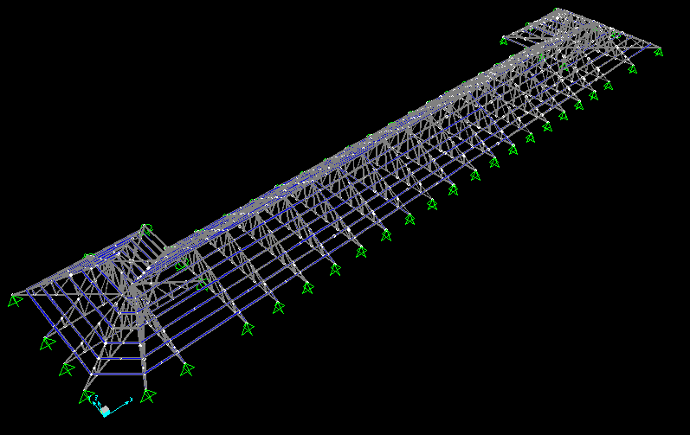

Figure 4. Three-dimensional space layout sources: Researchers Team

According to Figure 5,6,7,8, the load entered in the structural software is

1. Dead Load 157,64 kg/m2

2. Live Load 135 kg/m2

3. Push Wind Load75,82 kg/m2

4. Pull Wind Load 57,37 kg/m2

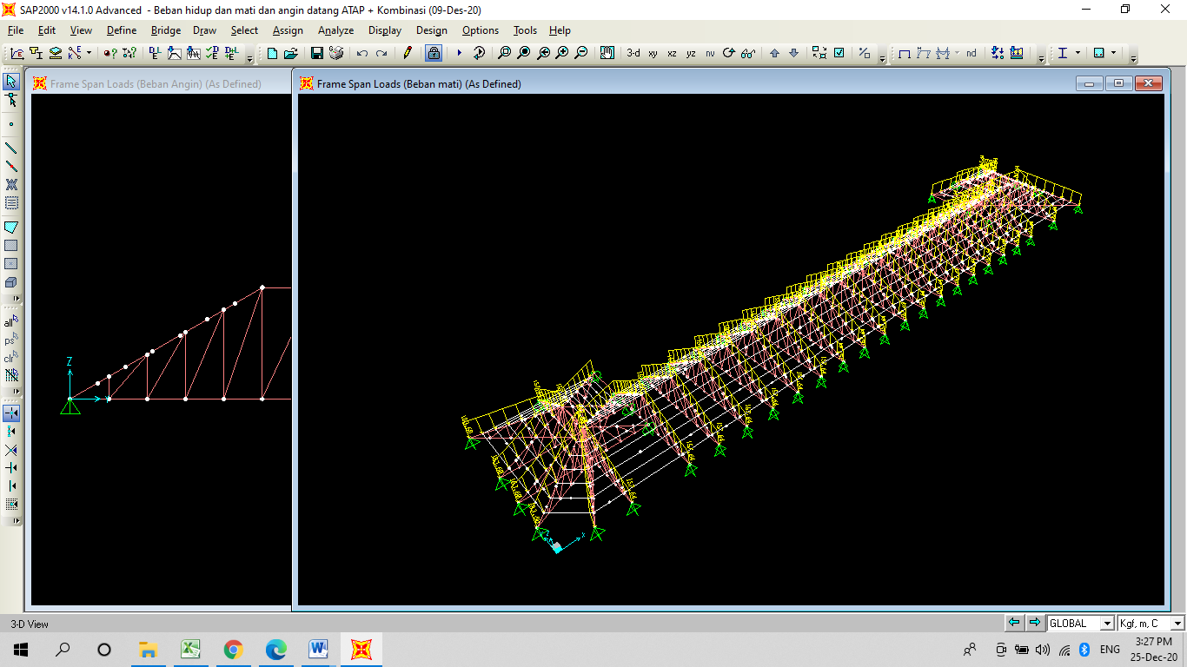

Figure 5, SAP2000 Program, Dead Load Input (Researchers Team)

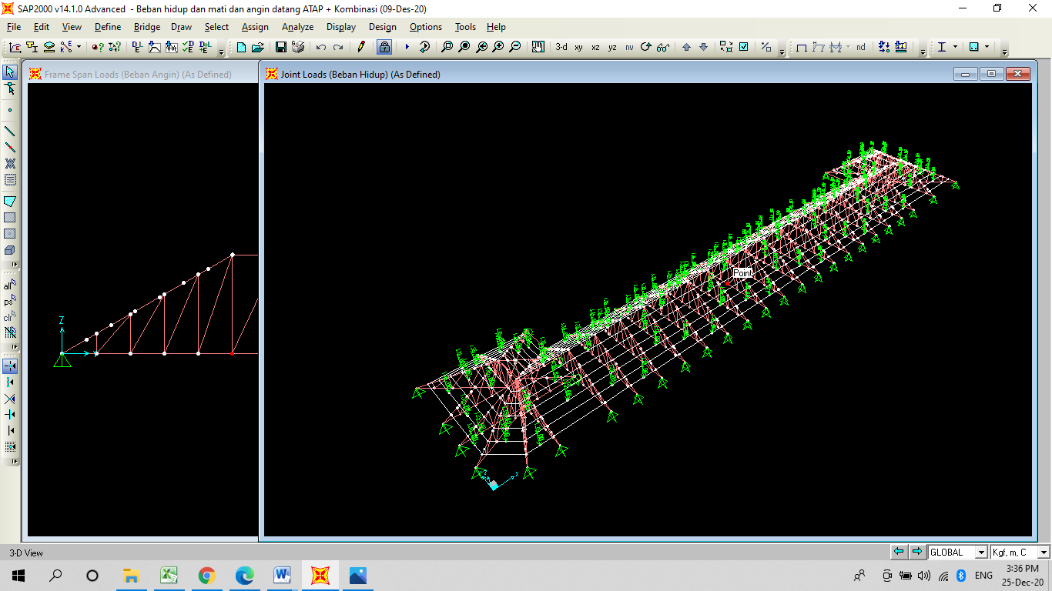

Figure 6. SAP2000 Program, Live Load Input (Researchers Team)

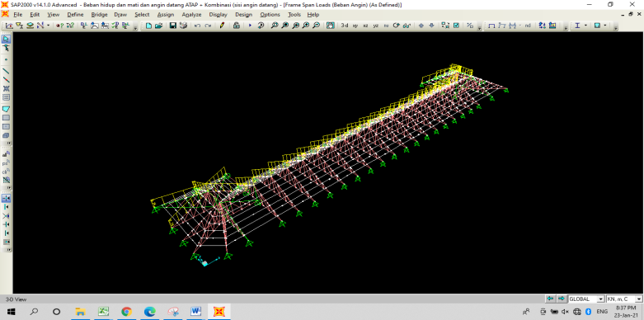

Figure 7. SAP2000 Program, push Wind Load Input (Researchers Team)

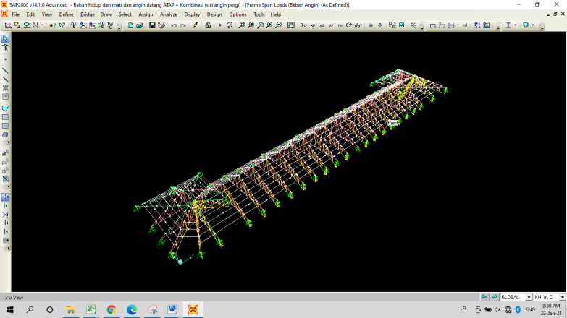

Figure 8. SAP2000 Program, pull Wind Load Input (Researchers Team)

**2.1. Overview**

|  |  |
| --- | --- |
|  |  |
| **Figure 9: Exsisting Visual** |  |

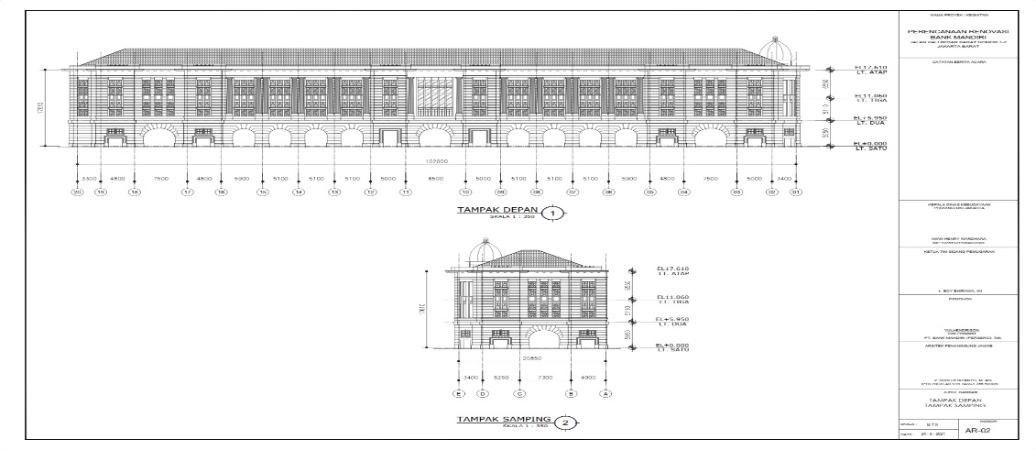

**Figure 10. In Front and Side View**

Figure 9. Existing visuals that must be maintained

Maintaining the visual, and finishing heritage buildings must be done. This was of course without neglecting the strength, stability, and rigidity of the structure. The heritage building was located in the old city of Jakarta, about 6 km away, the influence of seawater was quite high, and the elbow steel with the roof covering does not exist, and was easily porous. The implementation must be replaced with an elbow profile according to the existing dimensions. In addition, the weak structural steel dimensions are replaced with larger steel dimensions. Gap Research: There was no condition of the heritage building where the roof covering was damaged, or not maintained, steel truss roof and upper structure were damaged

but still maintained as original with retrofitting. The research team has to be careful when surveying and analyzing the profiles that can be maintained and those that couldn't. The steel roof truss from 100 years ago was of high quality, it was proven that the WF profile for the curtains beam was still good

**2.2. Decomposition Forces**

The dead load, live load, and wind load, the most important of which must be accepted by the frame roof structure, it is hoped that the roof structure will not be damaged for decades to come.

**2.3.Internally Computed Parameter**

Parameters as a reference are strength, stability, rigidity according to engineering standards, and small deformation of the allowable deformation. This is the concern of the research team, in addition to the profile of the existing bolt condition and the rust profile that needs to be replaced

**2.4.Detailing**

Detailing of the shape of the roof truss and material is attempted not to be different from the original condition, both roof structure work, roof covering truss, roof covering as well as vertical gutters. All of this is for the sake of preserving the heritage building

Maintaining the visual, and finishing heritage buildings must be done. This was of course without neglecting the strength, stability, and rigidity of the structure. The heritage building was located in the old city of Jakarta, about 6 km away, the influence of seawater was quite high, and the elbow steel with the roof covering does not exist, and was easily porous. The implementation must be replaced with an elbow profile according to the existing dimensions. In addition, the weak structural steel dimensions are replaced with larger steel dimensions. Gap Research: There was no condition of the heritage building where the roof covering was damaged, or not maintained, steel truss roof and upper structure were damaged

but still maintained as original with retrofitting. The research team has to be careful when surveying and analyzing the profiles that can be maintained and those that couldn't. The steel roof truss from 100 years ago was of high quality, it was proven that the WF profile for the curtains beam was still good

**2.2. Decomposition Forces**

The dead load, live load, and wind load, the most important of which must be accepted by the frame roof structure, it is hoped that the roof structure will not be damaged for decades to come.

**2.3.Internally Computed Parameter**

Parameters as a reference are strength, stability, rigidity according to engineering standards, and small deformation of the allowable deformation. This is the concern of the research team, in addition to the profile of the existing bolt condition and the rust profile that needs to be replaced

**2.4.Detailing**

Detailing of the shape of the roof truss and material is attempted not to be different from the original condition, both roof structure work, roof covering truss, roof covering as well as vertical gutters. All of this is for the sake of preserving the heritage building

|  |  |  |
| --- | --- | --- |
|  |  |  |
| a.Bolt joint | b. Bracing | c. Plafond hanger |
|  |  |  |
| d. Roof beam | e. Roof and survey team | f. horizontal rainy gutter |

Figure 11 a,b,c,d,e,f,g Exsisting Detail Roof Structure and Roof

The facade must be retained like its original form, as well as the details of the roof knick-knacks are also made as before, namely bolt connections made according to the supporting structure, namely bracing, ceiling hangers, roof beams, roofs, and gutters, the principle is even though the roof structure strengthened by replacing the porous and damaged but the shape of the roof, the structure of the roof and the details are retained

**2.5. Choice of Output**

The main thing is to analyze the retrofitting of the heritage building so that it doesn't collapse. When replacing bolts, profiles are porous and rusty. The roof truss structure support sits not only in the existing building, but the base is given a steel plate base that supports the structure to the ground floor because it cannot rely on a low-quality concrete structure smaller than fc 14.53 mpa

**2,6 Internal Regulation**

Regulation Of The Minister Of Public Works And People's Housing Of The Republic Of Indonesia Number 19 the Year 2021 Concerning Technical Guidelines For The Implementation Of Cultural Heritage Building Be Conserved

Article 6. (1) b. As much as possible maintain authenticity

Article 6. (4) c. Careful and responsible use is based on the use of non-destructive techniques, methods, and materials.

**3. Result/ Preliminary Analysis**

The steel roof truss structure of the Heritage building that was researched with an age of more than 100 years can still be used. The shape of the roof, roof structure, and roof details that need to be replaced are made according to the original. This retains the glory of the building in its time, changes to the roof structure for strengthening do not prevent its authenticity from being retained. This can be an eternal history of the building, even though changing generations and the descendants of the previous generation can be nostalgic considering their parents who used to work

Based on the results of the SAP2000 analysis, it was found that the profile replacement on the roof truss type K2 members 161 and 214 with the number of bolts 2 pcs ( existing installed 3 bolt) on the 2L 80.80 profile, 3 pcs on the 2L profile 70.70, 2 pcs on the 2L profile 60.60, 2 pcs on the 2L profile 50.50, 2 pcs on 2L 40.40 profile and 4 anchors. With a deflection of 0.25 cm at a distance of 7.4 m and a distance of 4.1 m roof truss obtained a deflection of 0.11 cm.

Of the many elbow profile on the roof truss and curtain beam, the results of the computer output show that 2 members exceed the stress limit so the dimensions that need to be enlarged from the existing 70.70.7 profile dimensions of the double elbow can be seen in the image below:

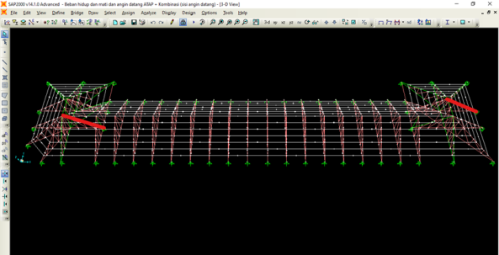

Figure 12. Two profile members 70.70.7 need to be replaced with double elbows 80.80.8. Two profile members 70.70.7 need to be replaced with double elbow 80.80.8 on type K2 as per figure 16

According to the output of structure roof software below

Figure 13 The output of the software shows that the compression member is not strong enough to withstand axial loads, the profile needs to be replaced with steel profile 2L 70.70.7 to 80.80.8 member 59 and member 284

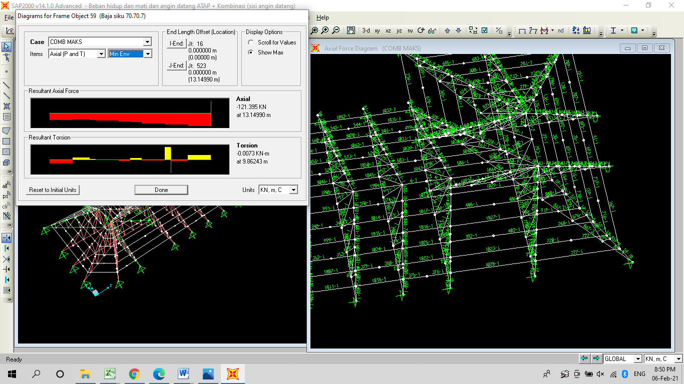

Figure 13 The output of the software shows that the compression member is not strong enough to stand axial loads, the profile needs to be replaced with steel profile 2L 70.70.7 to 80.8.8 member 59 and member 2 Mpa Elastic buck uncritical stress:

Fex = (1)

Fex = 192,42 Mpa Fcry = () . fy = 189,85 Mpa Fy/Fe<2,25

Other elbows 70.70.7 still meet the requirements

The deflection that occurs meets the requirements and is still smaller than what is allowed, meaning that the roof truss structure can support

The deflection that is used with the load of the installed tile. The existing connection uses bolts, the need for bolts is recalculated according to the package program output

The elbow profile roof frame is by the existing dimensions, except for 2 members that must be replaced 80.80.8, the other profiles still meet the stress requirements that do not exceed the allowable stress.

Deflection analysis on the roof frame with a distance between horses of 7.40 m was obtained from structural analysis with software for the deflection of 0.25 cm, the following is a picture of the deflection at a distance of 7.4 m that occurred and a deflection of 0.21 cm at a distance of 4.1 m roof frame

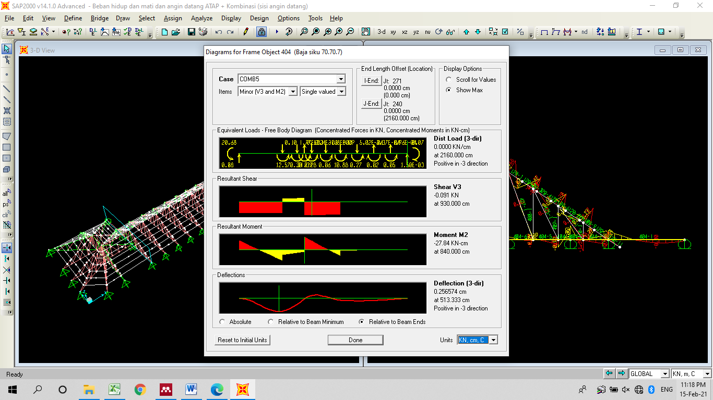

Figure 14: Deflection 0.256574 cm with a span of 2160 cm L to the inter-roof frame 7.4 m

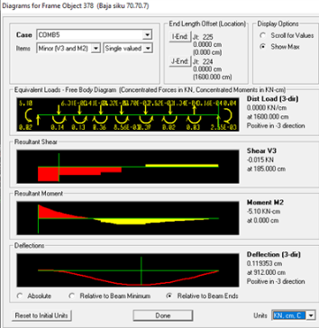

Figure 15 Defleksi 0.119353 cm length of 16 m to a distance of frame 4,1 m Member 378

**4, Discussion**

This discussion explains in a way that is easily understood by young engineers and serves as an example that scientific papers are easy to apply. The rods that need to be replaced if they could not match or are not sufficient with the accepted force, the number of bolts and anchors that need to be added as well as the required anchor length. The authors explain this so that it became a reference for readers who work in the building sector. The analysis carried out is simple as an example. Authors have the principle that the manuscript can be useful not only for academics but also professionals. The principle of repairing old buildings that must be maintained is not easy because construction must also be not sequential, the bottom roof structure must be supported to the ground floor because the concrete quality of the heritage building is very low. It is necessary to analyze the implementation not sequentially when designing the roof structure, the implementation is not sequential so that there is no weakening in adjacent areas which can result in tilting or collapsing.

Replacement of roof details that are damaged or less strong is replaced by paying attention to the authenticity and strength of roof details and roof structure. Everything must be done carefully and pay attention to the weak parts, replaced doesn't be the fatal impact

According to the Roof plan, the placement of the roof frame plan, K1, K2, K3, K4, and K5 roof frames, and details of the explanation according to the figures 16,17,18,19,20,21.

The entire roof structure from the floor plan and roof frame details as below:

1. Figures 16 Roof frame layout

2. Figure 17…Roof frame 1

3. Figure 18…Roof frame 2

4. Figure 19…Roof frame 3 and Roof frame 5

5. Figure 20…Roof frame 4

6. Figure 21 …Details I, II, II

We include all plans for retrofitting the roof truss structure to be applied throughout the world to be a reference for repairing old buildings, especially roofs

elbow roof frame

Reinforced Concrete

Brick wall

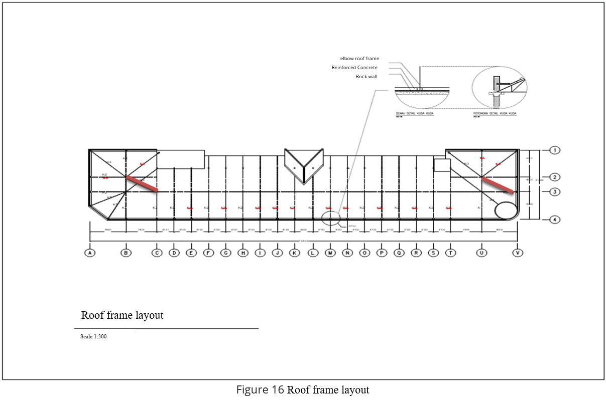

Figure 16. Roof Frame Layout

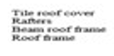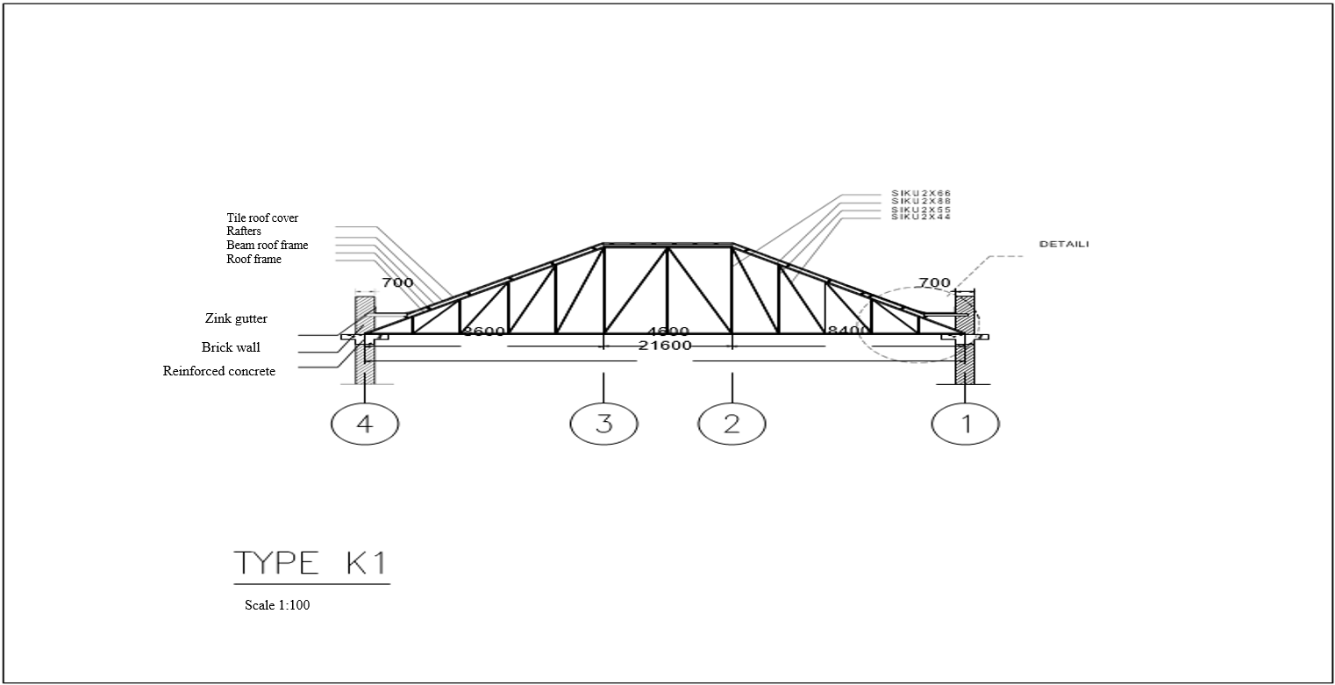

8400



4600

8600

21600



Figure 17 Truss K1

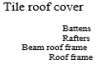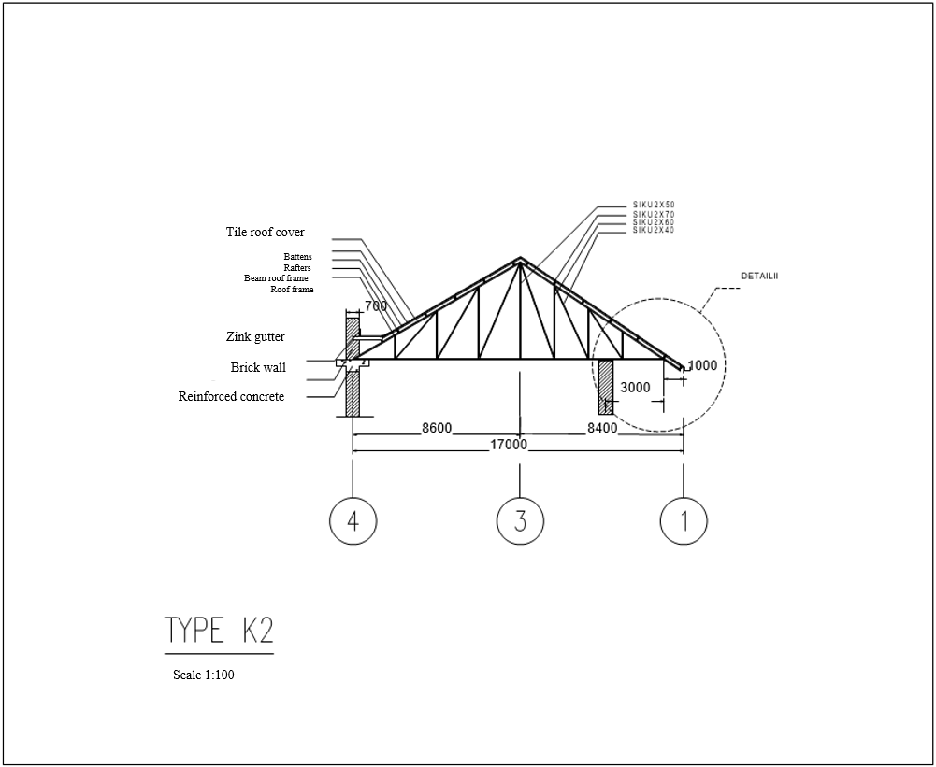

Figure 18 Truss K2

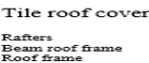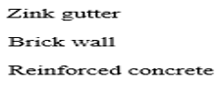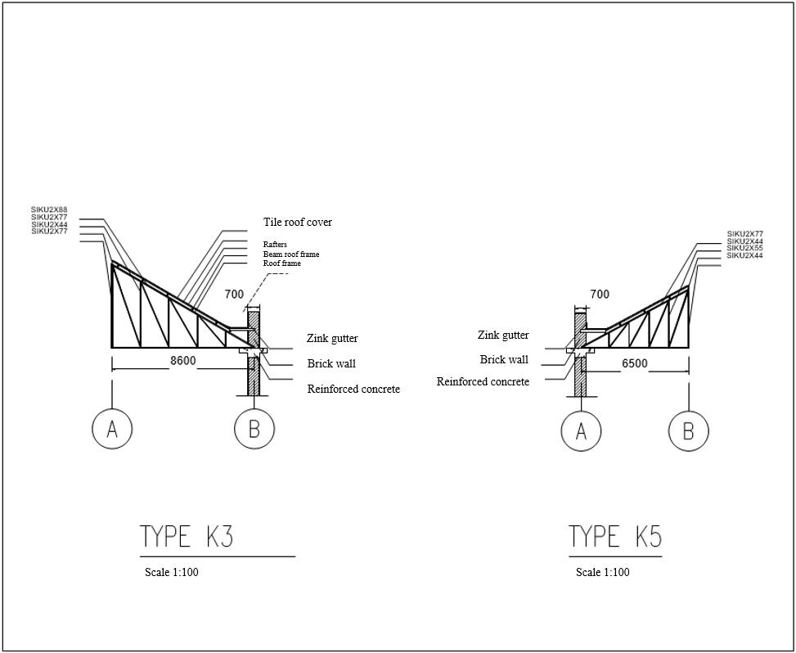

Figure 19 Truss K3 and K5

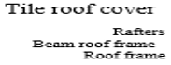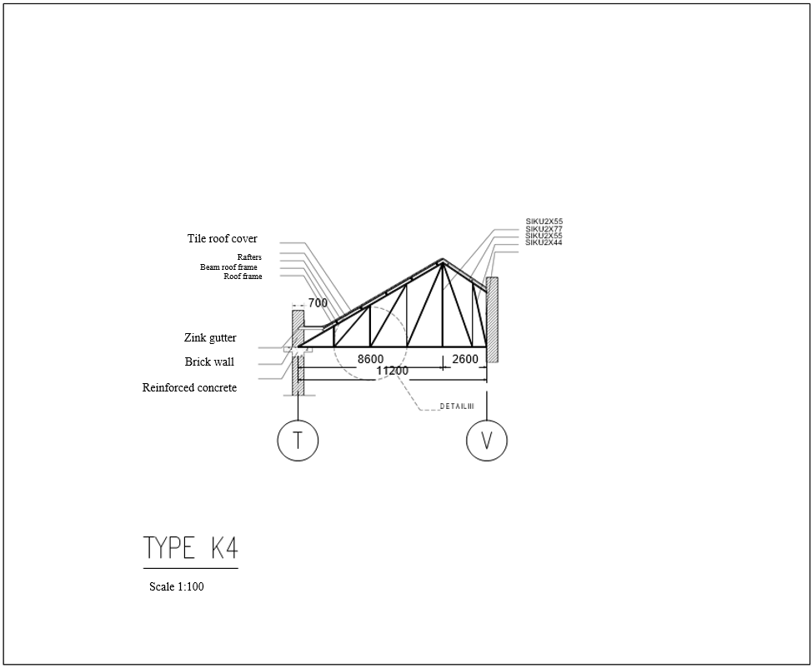

Figure 20 Truss K4

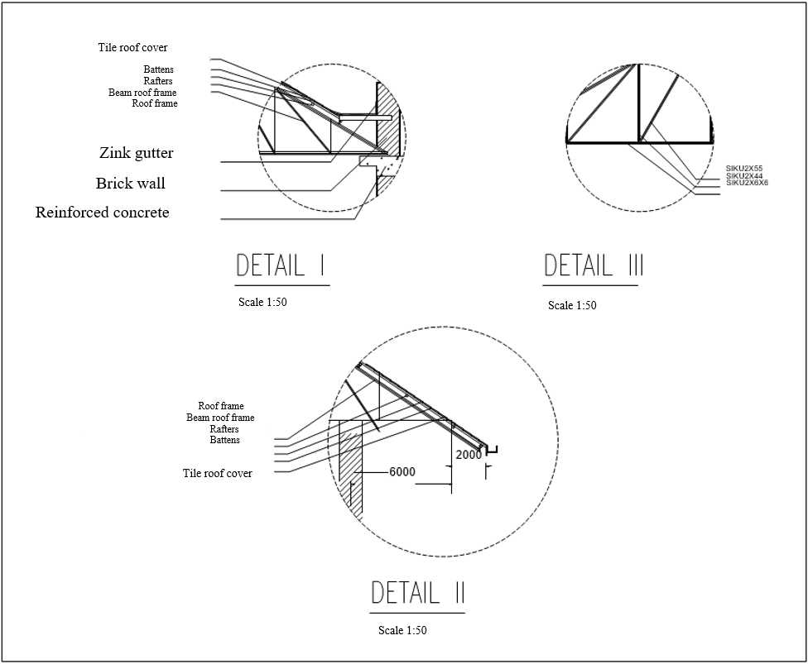

Figure 21 Detail I,II,III

Input material dimension Figure 22. 23 at below

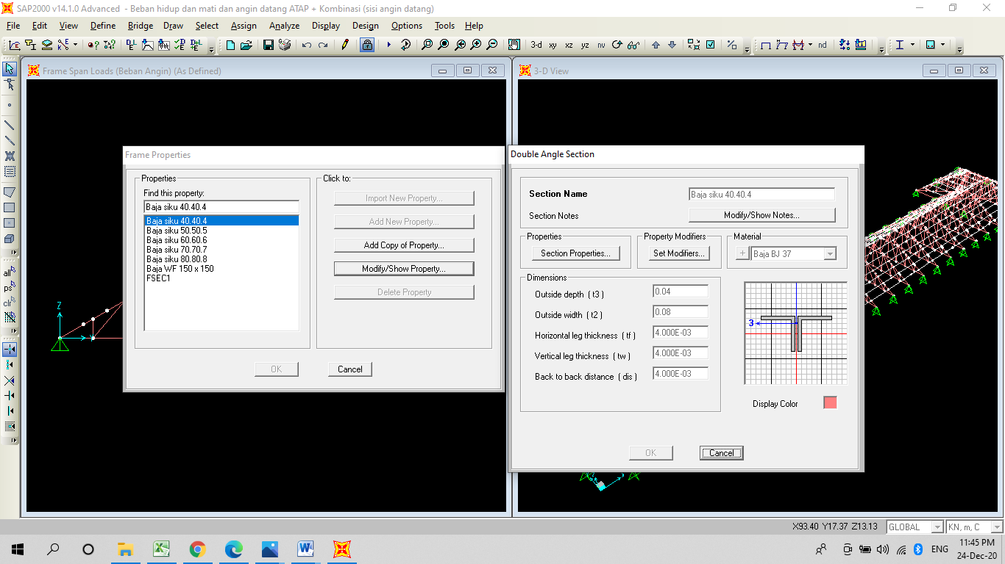

Sources Researcher Team: Input of SAP2000 Program Figure 22 Dimension of steel material double elbow

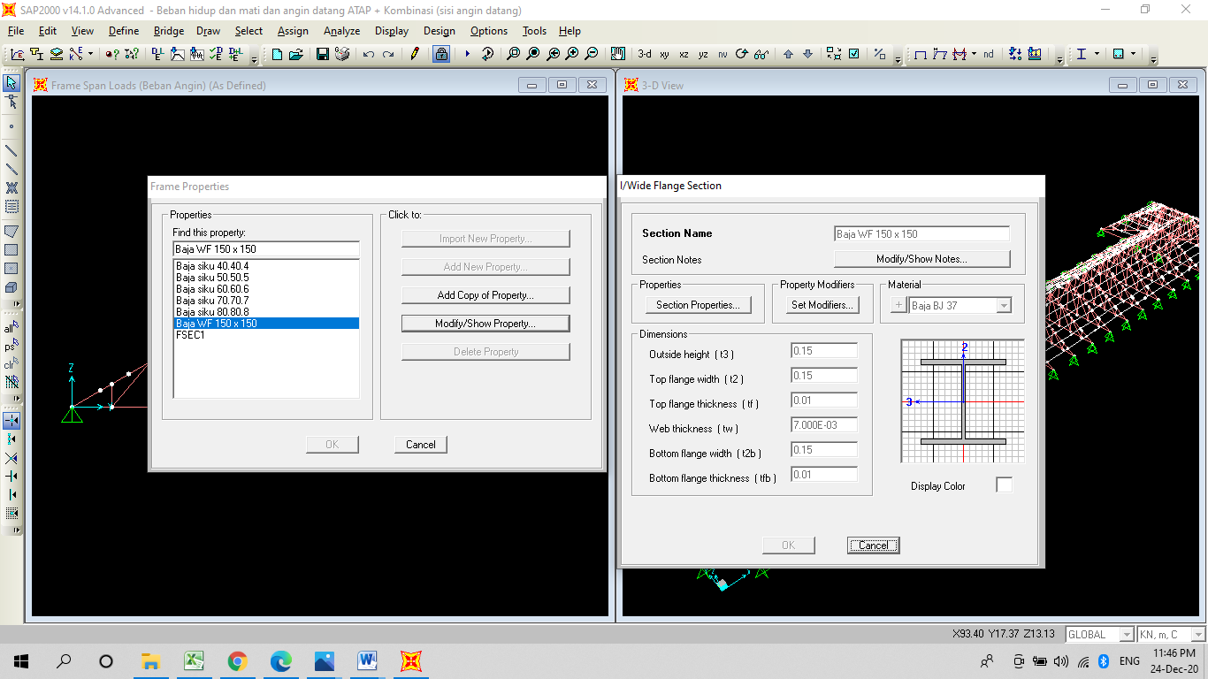

Sources Researcher Team: Input of SAP2000 Program Figure 23 Dimension of steel material IWF

Figure modeling the geometry can be seen in Figure 24 below

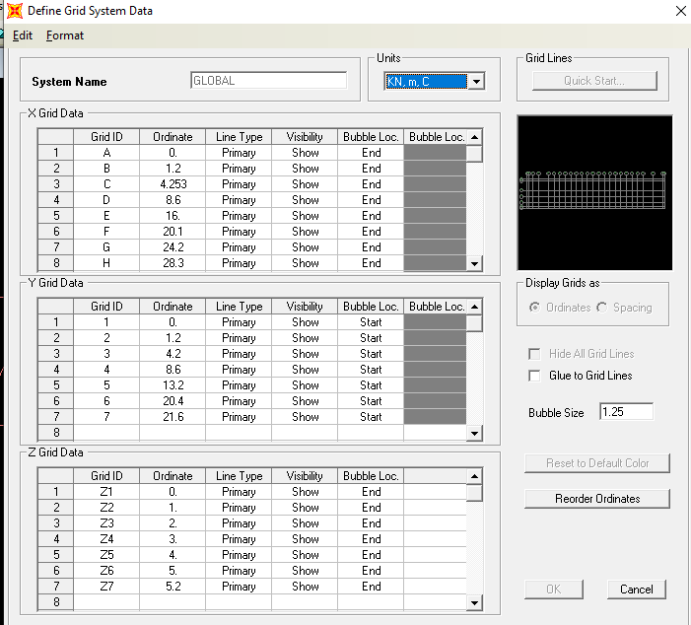

Figure 24 Input of Grid frame roof structure Sources Researcher Team: Input of SAP2000 Program

The tensile strength of the member compared to its value between the tensile strength based on the cross-section and the net section, the smaller value will determine the tensile strength. Gross cross-sectional tensile strength (Pnb): tb. Pnt1 = 406.08 kN

Net cross-sectional tensile strength (Pnn)

𝜙tn Pnt2 = 𝜙t Ae . (2)

Fu = 451,77 kN Pnt = 451,77 kN

For other profiles, the output diagram meets the requirements according to figures 25, 26,27 below

1. Double elbow steel profile 60.60.6 Member no 560 Span L- 5.50364 P max elbow 60.60.6 member no 426 output software = 41,89 kN, yes it safe

Figure 25 Axial force. Double elbow steel profile 60.60.6 L 5.44256 KN TENSION

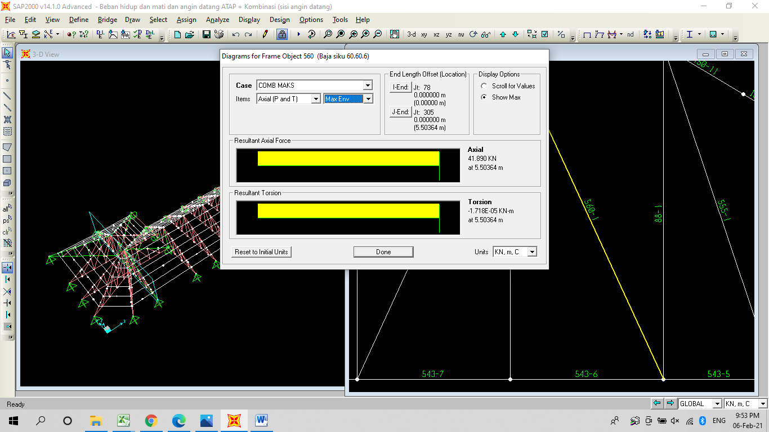

Figure 25 Axial force. Double elbow steel profile 60.60.6 L 5.44256 KN tension

2. Double elbow steel profile 50.50.5 Span L=5.44256

P max elbow steel profile 50.50.5 member no 426 output software = 28.93 kN, yes it safe

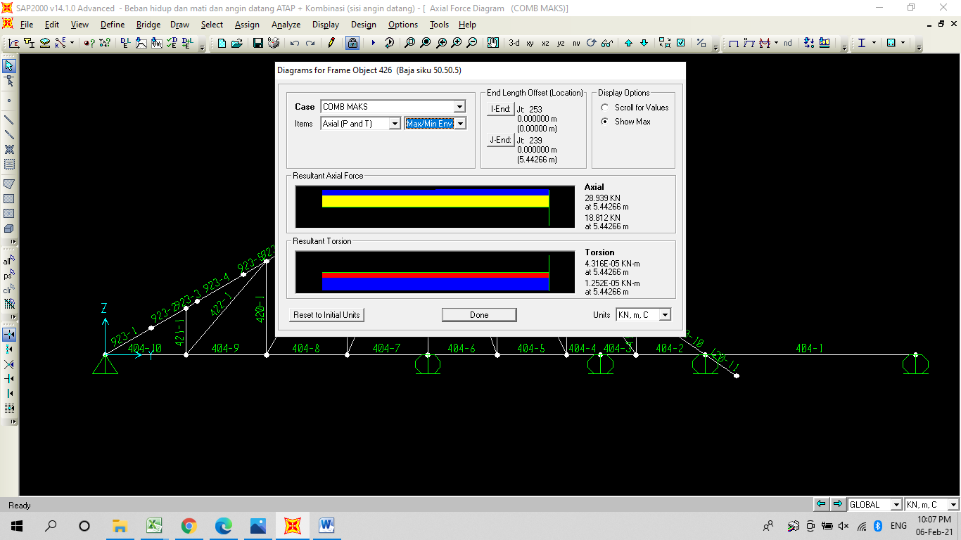

Source : Author: output software SAP2000

Figure 26 Axial force. Double elbow steel profile 50.50.5 Span L=5.44256

3. Double elbow steel profile 40.40.4 span L=5.42041 tension

Double elbow 40.40.4 Member no 581 biggest force

P max elbow 40.40.4 output software = 23. 41 kN, yes it safe

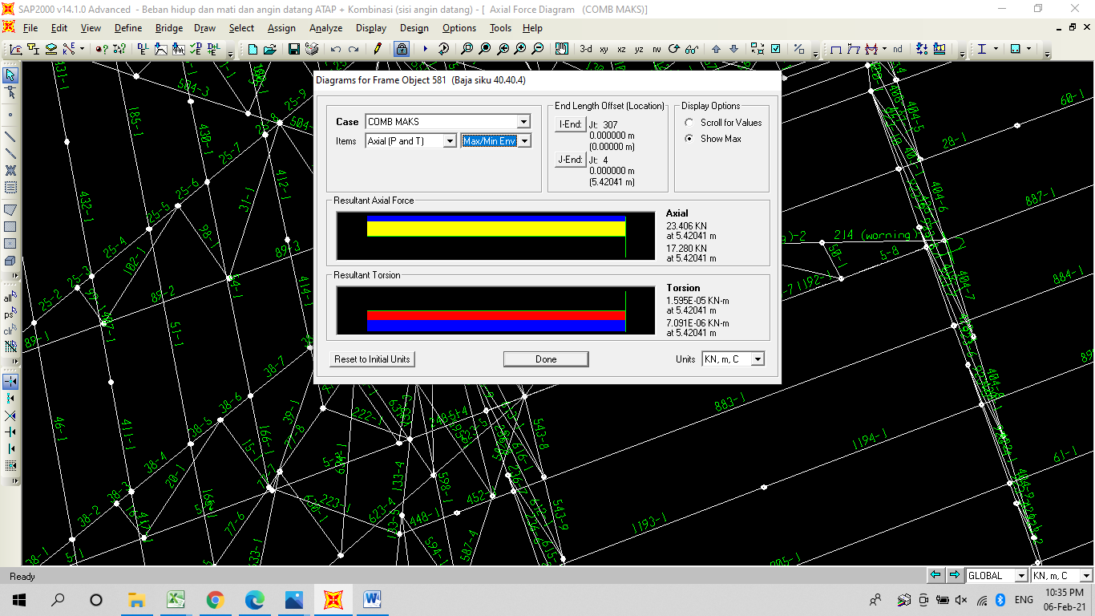

Source: Author: output structure software SAP2000

**Figure 27: Axial force. Double elbow steel profile 40.40.4**

In the design of compression elements, the strength will be taken into account in the following conditions:

A. Two compression members 127.95 kN and 121.39 kN in members 284 and 59 must be replaced. 2L profile 80.80.8

: Compression member 59 lengths 13.14990 m supported by another member so that the span length is 2.452 M so that the slenderness value is small

Fcrx=192,42 Mpa Fcry=189,85 Mpa

Slenderness value 2L 80.80.8 (127.95 KN)

Table B4.1a of SNI 1729-2015.

The slenderness of the rods: = 10 < r then it is a non-slender element

Element slenderness : = b/t = 10

Slimness limit : r = 0.45 . E/Fy = 12.98

because < r it is a member a non-slender

The compressive strength of the member is compared to its value between the strength based on the view of flexural buckling and flexural torsional buckling, the smaller value will be determined as the compressive strength.

Maximum compressive stress

Overview of flexural buckling: Fcr1 = 142.82 Mpa

Overview of torsional buckling and flexural torsional buckling: Fcr2 = 193.32 Mpa

Stress used Fcr = 142.82 Mpa

Compressive reduction factor c = 0.90

member compressive strength:

𝜙c . Pnc = 𝜙c .(3)

Fcr . Ag = 316,203 N. Ratio of strength to compression force Pu/ϕPnc = 0,40 < 1,0

B. Overview of flexural buckling, Article E.3 SNI 1729 2015)

Connecting plate thickness: tp = 8 mm

Effective length factor (Appendix no. 7.2.3.a SNI 1729-2015) K = 1.0

Limit ratio : (KL/r). max = 135.96

Slenderness Ratio ($\frac{KL}{rxg}$) =. max = 4,71 $. √\frac{E}{fy}$ (4)

C.Torsional buckling dan Flexural-Torsional Buckling*,* clause E.4 1729 2015)

Plastic buckling critical stress: Fex = = 192,42 Mpa (5)

$\frac{fy}{fex}$ = $\frac{240}{192,42}$ = 1,24 < 2,25

Critical  (6)

→ because $\frac{KL}{rxg}$ < 4,71 √ $\frac{E}{fy}$ and $\frac{fy}{fex}$ < 2,25 then (7)

${658 }^{\frac{fy}{fex}}$) . fy 142,83 Mpa

The double elbow joint profile (installed on all members), can be seen in Figure 28 below:

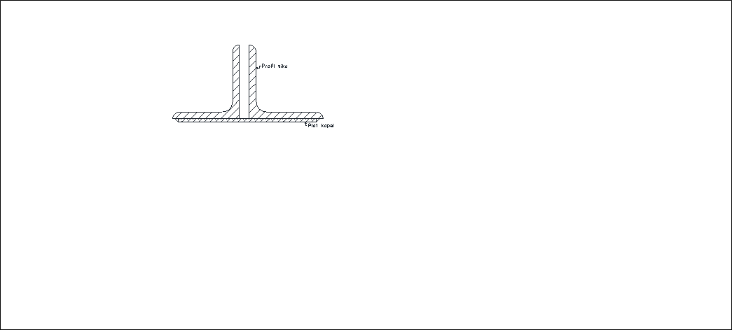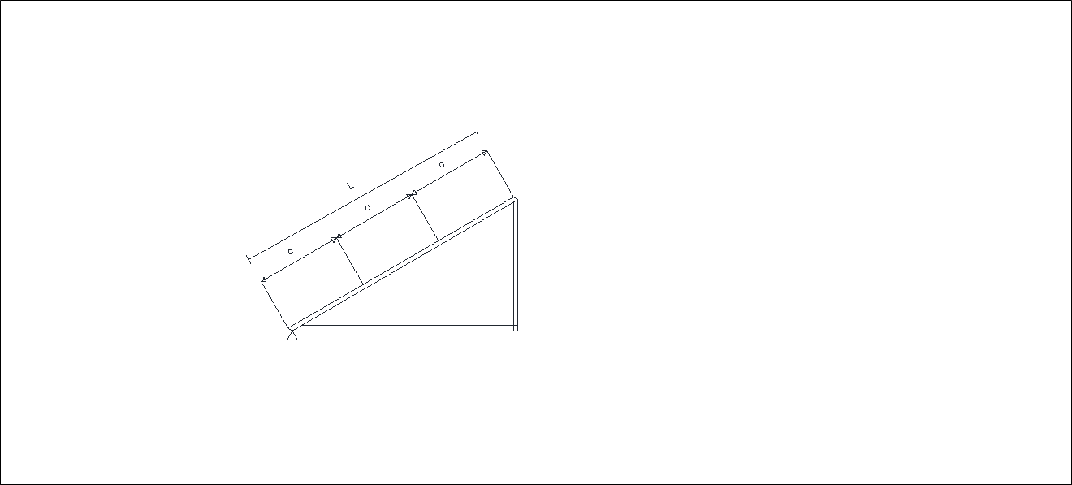

Source: Author AutoCAD drawing

Figure 28 Coupling plate and coupling plate position pieces

Slenderness ratio :Ki = 0,50 (Pasal E6.1b SNI 1729 2015, for back to back elbow profile

()o = )m (8)

→ because $\frac{a}{ri}$ < 40 then:

(m =( )o = 67,60 < max

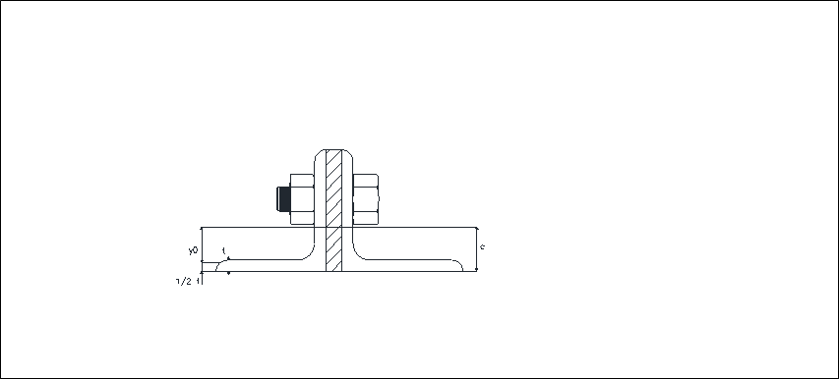

Source: Author AutoCAD drawing, diameter bolt 13 mm

Figure 29 Double elbow profile sliding center position

shear center coordinate : x0 = 0

y0 = c - . t = 19 mm

The radius of polar shear center to shear center :

ro = ) = 47,59 mm

Torsion (Dewobroto W, 2015)

J = . (2b - t) t 3 = 51882,66 mm4

Critical Stress (clause E.4 SNI 1729-2015) :

Fcry (9)

→ because ()m < 4,71 $\sqrt{\frac{E}{fy}}$ and $\frac{fy}{feym}$ < 2,25 then:

Fcry = () . fy = 189,85 Mpa

Fcrz = 2 . G. $\frac{J}{Ag}$. Ro² = 1434,08 Mpa

H *=* 1 - $\frac{xo²+yo²}{ro²}$ = = 0,84

cr2 = x 1 – $\sqrt{1- \frac{4 . fcry . fcrz . H }{(fcry+fcrz)²}}$ (10)

= 193,32 Mpa

Tensile

a.Overview of the tensile strength in the net cross-section and, the bolt connection is reviewed

Tensile strength (*Put*) 110,7 kN member no 89

Profile : 2L.70.70.7 Profile 2L.70.70.7

Area(*A*g) : 1880 mm2

Member span (*L*): 2000 mm (the most)

Tensile strength profile 2L.70.70.7

Pnt1 = Ag . Fy = 451200 N → 451,2 kN

Tensile strength reducing (Pnb) :

𝜙tb . Pnt1 = 406.08 kN

Connection eccentricity : *x* = c = 20 mm

Shear lag factor : U = 1 – ( $\frac{x}{lb}$) = 0,80

1. Overview of tensile yield conditions in net cross sections This review bases tensile strength on net cross sections and the tensile strength of the material, reviewed in the case of bolted connections (Chapter D.2.b SNI 1729-2015).

Connection eccentricity: *x* = c = 20 mm

Shear lag factor : U = 1 – ( $\frac{x}{lb}$) = 0,80

The connection bolts reviewed in this analysis are all types that exist in the steel truss profile, while the profile member under review is taken the largest axial force on each steel profile, the connection plate is 8 mm. The results of the analysis can be seen below

The shear strength of the bolt is calculated according to the provisions of Article J3.6 of SNI 1729-2015 as follows. Strength reduction factor : s = 0.75

Bolt cross section (cross section without thread)

*Ab* = . db 2 = 132,66 mm.

Shear strength= 𝜙Rnv = 𝜙 Fnv . Ab (11)

Shear strength = 45469 N→ 45,47 kN. Bolt bearing strength 2,4 . 𝜙 . db . t. fup = 60606 N → 60,60 kN

1. Steel profile 2L 80.8.8

The highest number of bolts required in the profile 2L 80.8.8 J 127.95 kN 2L 80.8.8 : : (127.95 )/(45.47) = 2.813943 = 3 bolts. There are a maximum of 3 installed existing ones, while the others only need 2 bolts with a diameter of 13

1. Steel profile 2L 70.70.7

Several bolts required for profile 2L 70.70.7: = 2.67 → 3 bolts Existing bolts 3 bolts for each connection. Several other bolts are required on 2L profile 70.70.7:= 1,958 → 2 bolts. The number of bolts required for the 2L profile is 70.70.7:= 1.689 → 2 bolts. BT 161 (89. 03 KN) , BT 214((76.81 KN)

1. Steel profile 2L 60,60,6

Number of bolts required for profile 2L 60.60.6 : (41.89)/(45.47) = 0.92 → 1 piece, min 2 bolts. Review member no 560 P max = 41.89 kN → SAP2000 output . span length=5.5036m

1. Number of profile bolts needed 50.50.5 rods 426 L=5.4425628.93 kN SAP2000 output: (28.93)/(43.29) = 0.66 → 1 piece, min 2 bolts
2. Number of profile bolts needed 40.40.4 : (23.41)/(34.63) = 0.67 → 1 piece min 2 pcs , tensile bolts

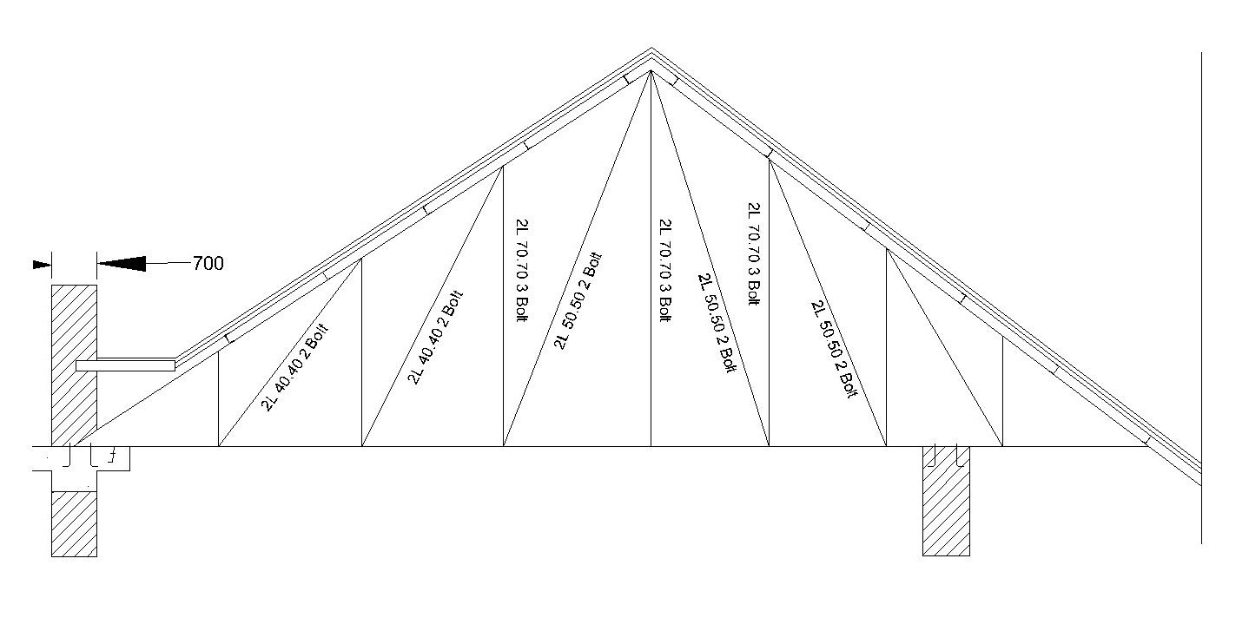

Figure 30 Bolt requirement on profile

**Base Plate and anchor**

Some of the input data that will be used in calculating the base plate design are as follows:

Anchor diameter 19 mm.

The anchor shear strength is 84.18 kN. Anchor bearing strength 126.5 kN Horizontal reaction (RH) = 70.35 kN. Vertical reaction (RV) = 116.72 kN

R result in = √((RH)²+(RV)²) = 136.28 kN 4 anchors are used. Allowed anchor strength 84.18 KN

Number of anchor requirements: (136.28) / (84.18) = 1.61 →2 anchors

4 pieces of anchor minimum and 4 pieces of the anchor are used. Force on 1 anchor = 34.08 KN

**Anchor Length**

Based on the split tensile test against the compressive strength of 6.323% , the split tensile strength of the concrete = 1.58075 mpa (Pandaleke RE Wndah RS 2017.) Shear strength of the anchor is Vsa= 3 . Ab. Fnv = 84.18 kN. Anchor support strength is 2.4. .db .t.fup = 126.54 kN

Bolt cross section (cross section without thread)

Ab = /4 . db 2 = 283.39 mm2.

For a review of shear loads with ductile quality 3 = 0.65

The length of the anchor is calculated when getting tensile force so that the anchor is not uprooted.

The vertical force is divided by the anchor blanket and the concrete stress.

Pa = RV/(π . da . fc concrete ) = (12)

= (34080/( 3.14*19*12.3) = 46.42841mm plus base plate and grout thickness s2 = (3 . Pa) + tp = (3 . 46.42) + 13 =152.2852 mm Anchor length used is 16 cm

**5. Conclusion**

The author analyzed the calculation of the continued non-sequential construction, but it needs to be executed properly and supported by strengthening. If the retrofitting was successful, it would become a heritage building that was very useful for the younger generation and the older generation. The roof is the crown of the building, if the roof is strong and has the same shape and returns to a similar original, it will be seen from a distance as an icon of the building. It will be more attractive to tourists of all generations, the older generation is nostalgic, while the younger generation is to understand the history of the era when the building was built and triumphed

Heritage buildings, especially roofs, can be used after retrofitting the entire roof structure, up to the roof details as strengthening and complementing the function of the roof has been carried out on roof frames subjected to bending, tensile, buckling, torsion, and deflection. The deflection of the roof structure of the heritage building meets the requirements then the roof frame structure meets strength, stability, and stiffness provided that rusty steel profiles, bolts, and anchors are replaced and the amount is by calculation of the output of the software. Note that the design was based on the construction that was not sequential but alternating, if carried out sequentially it will weaken in certain areas, it could cause it to collapse and the supporting roof installed until the ground floor. The research team had to check the bolts, the anchors were in their proper position and not loose, and nothing was rusted.

The research team tried the original roof had to be retained. Besides our manuscript, hope published for a simple guide for young engineers to construct heritage build and academies to understand the philosophy of repairing or strengthening old buildings or heritage buildings

**Author Contributions and Acknowledgments**

Thank you to the team of building owners and managers who provided survey opportunities and the team of investigative consultants who provided data on 2016 the results of testing the roof structure of a heritage building

Nusa Setiani Triastuti created heritage building research, choice of structural system, detailed roof, and roof material were retained. Rico Turnando was the survey leader and the input of structure software. Indriasari did recheck the output software and rechecked manuscript

1. **Conflict of Interest**

The authors got a chance to roof survey together with handymen who usually install roofing materials on other heritage building projects, the authors felt fortunately

1. **Funding**

The authors did get no research funding and no conflict of interest for our research team.

9. **Competing Interest**

The research team tried and proved that the building was by the level of very severe damage, even though it was difficult when the survey entered the building, they were worried that the material would be dropped and injure the research team, danger, especially when monitoring the roof so that the footing was with assistive devices without existing footing. Design must be careful with attention to implementation, in the order to not continue the work area but alternating (jump) sequences the work area before the overall roof structure is dismantled. The level of difficulty and danger during the survey, design,d, and implementation still high maintains heritage building, although it is easier to dismantle, the structure and roof covering are similar to the existing

|  |  |  |
| --- | --- | --- |
|  | C:\Users\Gigabyte\Downloads\WhatsApp Image 2020-11-10 at 11.51.24.jpeg |  |

a.Heritage Building View,1921 b, heritage building roof c. 3D building

|  |  |  |
| --- | --- | --- |
|  |  |  |

d.Survey team at roof e, Rooftop f Roof gutters

Figure 31: Documentation Survey Team

**Reference**

Acosta T, S (2021) Risk assessment of low-rise educational buildings with wooden roof structures against severe wind loadings Journal of Asian Architecture and Building Engineering Received 19 Jul 2020, Accepted 23 Mar 2021, Accepted author version posted online: 31 Mar 2021, Published online: 09 May 2021 <https://doi.org/10.1080/13467581.2021.1909596>

[Cestari](https://www.tandfonline.com/author/Bertolini+Cestari%2C+Clara) C. B., Tanja M.(2008) Conservation of historic timber roof structures of Italian architectural heritage: diagnosis, assessment, and intervention. Journal of Architectural Heritage(2008) Pages 632-665 <https://doi.org/10.1080/15583058.2018.1442523>

[Departemen Pekerjaan Umum. (2002)]. Tata Cara Perencanaan Struktur Baja untuk Bangunan Gedung. Standar Nasional Indonesia. [Public Works Department. (2002)]. Procedures for Planning Steel Structures for Buildings. Indonesian National Standard.

Dewobroto W (2015) (SNI 1729:2015 dan Era Baru Perencanan Baja Berbasis Komputer Seminar Nasional “ Inovasi Struktur dan Rekayasa Bahan dalam Teknologi Konstruksi jurusan Teknik Sipil. Politeknik Negeri Jakarta Depok 5 Desember 2015 hal 1

[Giuriani](https://www.tandfonline.com/author/Giuriani%2C+Ezio)E, Marin A (2008) Wooden Roof Box Structure for the Anti-Seismic Strengthening of Historic Buildings. Journal of Architectural Heritage(2008) Pages 226-246 |  <https://doi.org/10.1080/15583050802063733>

Gutiérrez A.C,  [Jimenez](https://www.tandfonline.com/author/Borrallo-Jimenez%2C+Milagrosa) M.B (2018) Methodology of Restoration of Historical Timber Roof Frames. Application to Traditional Spanish Structural Carpentry.Journal of Architectural Heritage(2018). Pages 51-74 <https://doi.org/10.1080/15583058.2018.1506833>

HEGDE R., YOGESH , CHAVHAN S (2018). Comparative study on analysis of steel truss structure and rigid frame by using STAAD PRO International Research Journal of Engineering and Technology (IRJET) e-ISSN: 2395-0056 Volume: 05 Issue: 09 | Sep 2018 www.irjet.net p-ISSN: 2395-0072

Indonesia, S. N., & National, B. S. (2015)]. Spesifikasi untuk bangunan gedung baja struktural. *(Specifications for structural steel buildings).*

[Indonesia, S. N., & National, B. S. (2018)]. Beban desain minimum dan kriteria terkait untuk bangunan gedung dan struktur lain.(*Minimum design loads and related criteria for buildings and other structures)*

Kozak [D. L., Liel](https://www.sciencedirect.com/science/article/abs/pii/S016747301500017X#!)[A.B.](https://www.sciencedirect.com/science/article/abs/pii/S016747301500017X#!) (2015) Reliability of steel roof structures under snow loads [Structural Safety](https://www.sciencedirect.com/science/journal/01674730) Pages 46-56 [Volume 54](https://www.sciencedirect.com/science/journal/01674730/54/supp/C), May 2015, <https://doi.org/10.1016/j.strusafe.2015.02.004>[Get rights and content](https://s100.copyright.com/AppDispatchServlet?publisherName=ELS&contentID=S016747301500017X&orderBeanReset=true)

Lourenço P.B, Ciocci M.P, Greco, Karanikoloudis G,  [Cancino](https://www.tandfonline.com/author/Cancino%2C+Claudia) C, [Torrealva](https://www.tandfonline.com/author/Torrealva%2C+Daniel) D.(2018) Traditional techniques for the rehabilitation and protection of historic earthen structures: The seismic retrofitting project. International Journal of Architectural Heritage (2018) p 15-32 <https://doi.org/10.1080/15583058.2018.1497232>

Martínez J.M, Montero P.G, Peguero C.N, Diaz J,I (2004) Comparative Study between Rigid Frames and Truss Steel Structus . Agricultural Engineering International: the CIGR Journal of

Scientific Research and Development. Manuscript BC 03 010. July 2004.

Mulyadi, R., & Wijaya, S. (2020)]. Analisa Struktur Rangka Atap Gedung Rektorat Universitas Muara Bungo (Rangka Kuda-Kuda Type Single Frame Beam). Jurnal KOMPOSITS, 1.

Rambhau P. R, Wakchaure M.R. (2017) Review paper on the alternate design of roofing system Impact Factor: 4.116 IC™ Value: 3.00 February 2017 CODEN: IJESS7 page 765 pp:761-765 http: // www.ijesrt.com© International Journal of Engineering Sciences & Research Technology

Regulation Of The Minister Of Public Works And People's Housing Of The Republic Of Indonesia Number 19 Year 2021 Concerning Technical Guidelines For The Implementation Of Cultural Heritage Building Be Conserved Article 6.(1) b. Article 6.(4) c

Ronny E. Pandaleke, Reky S.Windah (2017) perbandingan uji tarik langsung dan uji tarik belah beton (*Comparison of direct tensile test and split tensile test of concrete* ) Jurnal Sipil Statik Vol.5 No.10 Desember 2017 (649-66) ISSN: 2337-6732

Salmon, C.G., dan Johnson, J.E., (1997), Struktur Baja: Desain dan Perilaku, Jilid 1,2, Edisi kedua, (Steel Structures: Design and Behavior, Volume 1,2, Second Edition)Penerbit Erlangga, Jakarta. , 1997,

[Suhajri, A., & Dewi, S. H. (2016)]. Evaluasi Perencanaan Struktur Kuda-kuda Baja Gedung Kargo Bandar Udara (*Evaluation of the Strtuctural Design of Steel Roof Truss of Airport Cargo Buildings* ()Sultan Syarif Kasim II Pekanbaru. 16(April), 76–93.

[Wibaut](https://www.tandfonline.com/author/Wibaut%2C+Romain).R, Wouters I. Coomans T. 2019) Evolution of Early Iron Roof Trusses in Mid-Nineteenth-Century Belgium. Journal of Architectural Heritage(2019) Pages 963-978. <https://doi.org/10.1080/15583058.2019.1598517>

Yong Y,X. Qing[https://www.sciencedirect.com/science/article/abs/pii/S0267726117310643 - !](https://www.sciencedirect.com/science/article/abs/pii/S0267726117310643#!) F,L  [Zu L.H ,Shen](https://www.sciencedirect.com/science/article/abs/pii/S0267726117310643#!) Y. (2017) Vertical ductility demand and residual displacement of roof-type steel structures subjected to vertical earthquake ground motions <https://doi.org/10.1016/j.soildyn.2017.10.019>

Zhang) L.B.Y(2013). Nonlinear dynamic behavior of steel-frame roof structure with self-centering members under extreme transient wind load [Engineering Structures](https://www.sciencedirect.com/science/journal/01410296) Pages 819-830 [Volume 49](https://www.sciencedirect.com/science/journal/01410296/49/supp/C), April 2013, <https://doi.org/10.1016/j.engstruct.2012.11.005>[Get rights and content](https://s100.copyright.com/AppDispatchServlet?publisherName=ELS&contentID=S0141029612005718&orderBeanReset=true)